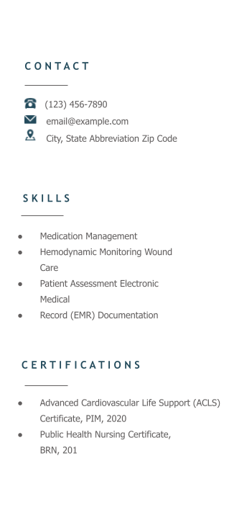

MICHELLE YOUNG, RN

Compassionate and detail-oriented Registered Nurse with five years of experience seeking a position at Downey Medical Center. Dedicated to exceptional patient care and support through strong interpersonal communication and an empathetic bedside manner. Looking to join a team of dynamic medical professionals with a commitment to quality healthcare service.

P R O F E S S I O N A L E X P E R I E N C E

REGISTERED NURSE
Eisenhower Health, Rancho Mirage, CA

February 2020 – Present

- Monitor up to four patients on the telemetry unit and assess as often as every 15 minutes to maintain standard level of care for cardiac and respiratory conditions, reducing inpatient admission times by 15%
- Interpret EKG results and telemetry strips, working closely with physician on duty to create and manage unique care plans for all patients
- Educate patients and family members on pre- and post-operative cardiac care with compassion to maintain patient satisfaction scores of over 90%
- Manage medication administration for assigned patients and evaluate patient condition in response to treatment plan

REGISTERED NURSE
California Medical, Glendale, CA

November 2017 – December 2020
- Measured vital signs, input data into EMR system, and recorded detailed patient histories
- Administered routine vaccinations to a variety of patients and dispensed appropriate educational materials

E D U C A T I O N & L I C E N S I N G

October 2017

CALIFORNIA REGISTERED NURSE LICENSE

September 2013 – June 2017 BACHELOR OF SCIENCE (B. S.) NURSING UCLA SCHOOL OF NURSING, Los Angeles, CA

