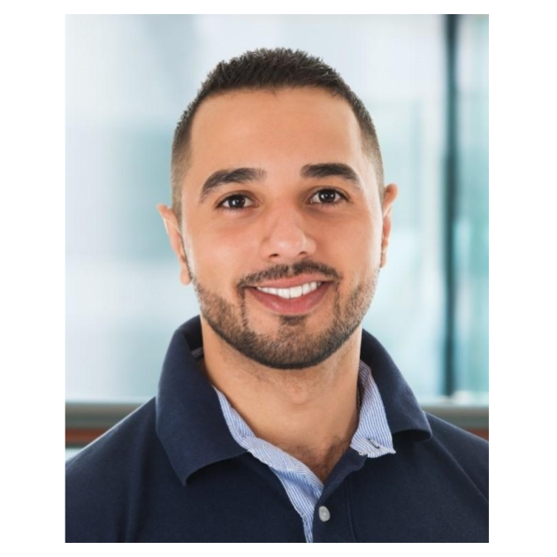
7




RAYMOND ORTIZ

A licensed physical therapist with five years of experience in orthopedic and neurologic rehabilitation. A proven track record of developing customized rehabilitation and treatment plans for diverse patient populations to reduce recovery times by up to 32%.
Contact  (123) 456-7890  raymondortiz@example.com  LinkedIn  Los Angeles, CA 12345  Key skills  - Manual therapy  - Patient education  - Orthopedic physical therapy  - Pain management  - Neurologic rehabilitation  Education  Doctor of Physical Therapy (DPT) | University of Southern California, Los Angeles, CA | May 2019  Bachelor of Science (B.S.) in Kinesiology | University of Michigan, Ann Arbor, MI | May 2016 | Professional Experience  Senior Physical Therapist | Coulsen Orthopedics, Los Angeles, CA  June 2018 – present  - Develop and implement customized treatment plans for over 300 patients, adjust rehabilitation plans based on patient progress, and reduce average recovery times by 17% in two years  - Manage a team of physical therapy assistants, and deliver training on clinical standards and patient-centered care, contributing to a 92% patient satisfaction rating  - Provide education to patients and families on recovery plans and at-home care to reduce post-treatment and surgical complications by 19%  Physical Therapist | Sanderson Physical Therapy  January 2018 – May 2018  - Created personalized rehabilitation programs for 150 patients recovering from strokes and major surgeries, educated patients and family members on treatment plans, and altered therapeutic approach based on individual patient needs  - Collaborated with multi-disciplinary teams to enhance the delivery of patient care and achieve positive clinical outcomes in 82% of cases  Certifications  - Orthopedic Clinical Specialist (OCS) | American Board of Physical Therapy Specialties | January 2020  - Cardiopulmonary Resuscitation (CPR) Certified | American Heart Association | June 2019

