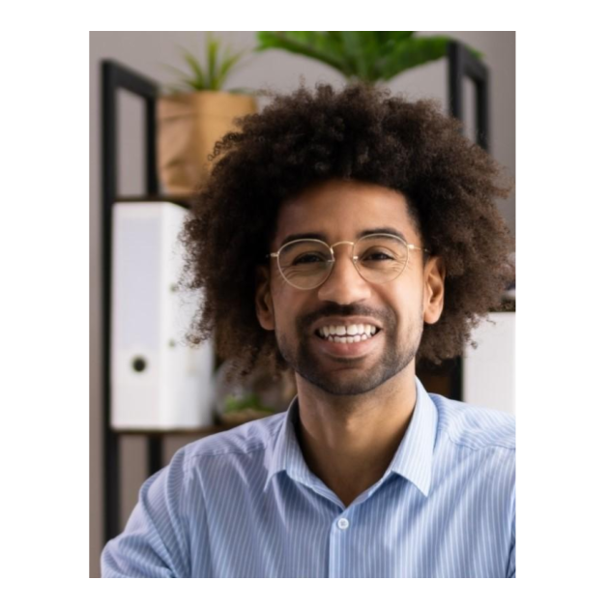



RAHEEM RICHARDSON

A dynamic social media specialist with seven years of experience in digital marketing, Google Analytics, and brand marketing. A proven track record of driving audience engagement and brand awareness for multi-million dollar product lines through data-driven content strategies.
Contact  (123) 456-7890  raheemrichardson@example.com  LinkedIn | Portfolio  Philadelphia, PA 12345  Key skills  - Social media strategy  - Paid social advertising  - Google Analytics  - Audience segmentation  - Brand development  Education  - Bachelor of Arts (B.A.) Marketing  September 2013 – June 2017  Drexel University, Philadelphia, PA | Professional experience  Social Media Specialist | November 2019 – present  BrewTech Co. | Philadelphia, PA  - Manage social media strategy and content development across Instagram, Facebook, and Twitter platforms, resulting in a 170% increase in engagement within the first year for a multi-million dollar home brewing equipment company  - Develop and execute targeted social media campaigns to support three new product launches, contributing to $2.7 million in sales revenue  - Analyze social media data and performance using Google Analytics and Hootsuite, optimize campaign strategies, and generate a 17% increase in click-through rates  Social Media Coordinator | June 2017 – October 2019  Edge Marketing | Philadelphia, PA  - Led all aspects of social media operations for six client businesses, aligned content strategies with target demographics, and increased followership by 150% to 220% across Facebook, Twitter, and Instagram  - Launched a highly targeted paid social campaign for a vegan food brand, which resulted in a 34% increase in online sales conversions over four months  - Tracked performance metrics and conducted market research to refine brand messaging, growing engagement rates by 59%  Certifications  - Hootsuite Social Marketing Certification | Hootsuite | 2020  - Google Analytics Certification | Google | 2019

