Laura Bennett
Experienced music curator with 11 years of expertise designing playlists for major brands and streaming platforms. Skilled in analyzing audience preferences and trends to deliver engaging content.

CONTACT
(123) 456-7890

PROFESSIONAL EXPERIENCE
Music Curator | StreamVibes, Portland, OR June 2017 - Present

email@example.com LinkedIn | Portfolio Portland, OR

EDUCATION
Bachelor of Science (B.S.), Music Business
University of Oregon, Eugene, OR December 2013

KEY SKILLS
Design over 500 playlists for a streaming platform with 1 million monthly users
Conducted audience research to optimize playlist engagement, increasing average listens by 30%
Collaborate with emerging artists to promote their work through curated features

Assistant Music Curator | BrandSound, Seattle, WA January 2014 - June 2017
Developed music libraries for corporate clients, tailoring selections to brand identities
Supported licensing agreements for major advertising campaigns

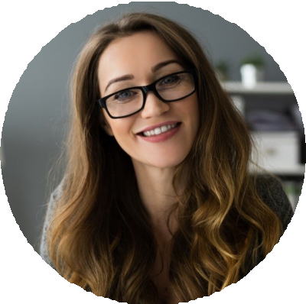




Playlist curation Music licensing Audience analytics Genre expertise
Collaboration with artists

