Sarah Lee
Creative counselor skilled in daily activity coordination
Day camp counselor with three years of experience creating engaging schedules and fostering a fun, inclusive environment for children aged 6 to 12.
PROFESSIONAL EXPERIENCE

CONTACT

(123) 456-7890
January 2023 - Present
Day Camp Counselor | Evergreen Community Camp | Portland, OR
Plan and facilitate arts and crafts sessions for 40+ campers
Manage daily schedules to ensure smooth transitions between activities Maintain open communication with parents, receiving positive feedback

email@example.com LinkedIn
Portland, OR
July 2022 - August 2023
Camp Volunteer | Green Pines Park | Portland, OR
Assisted staff with snack preparation and cleanup tasks Monitored playground activities to ensure safety

EDUCATION

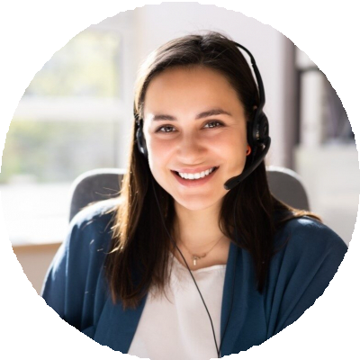


KEY SKILLS

Arts and crafts coordination Camper safety
Daily scheduling Positive reinforcement Parent communication
High School Diploma
Lincoln High School, Portland, OR | June 2022

