Zachary Baker

Student Phlebotomist

Undergraduate health-sciences major completing phlebotomy practicum with a 96% ﬁrst- stick rate. Eager to apply academic knowledge and clinical skills in a hospital setting.
Strong collaborator and quick learner.

CONTACT

(123) 456-7890
email@example.com LinkedIn | Portfolio City, ST

PROFESSIONAL EXPERIENCE

Phlebotomy Practicum | January 2024 - Present
University Hospital Lab, City, ST

Performed 150+ supervised draws, achieving 96% ﬁrst-attempt success
Assisted in labeling, centrifugation, and data entry in LIMS

Volunteer Medical Assistant | September 2022 - December 2023
Campus Student Health Center, City, ST

KEY SKILLS
Supported triage and vitals for 30+ patients daily Managed supply restocking and equipment sterilization


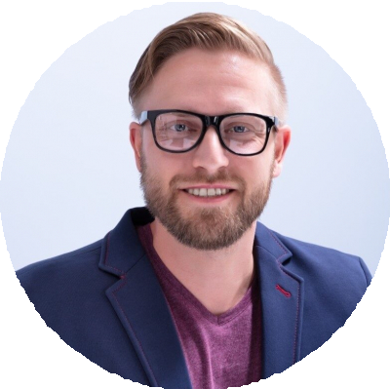




Clinical Rotations LIMS Data Entry Aseptic Technique Patient Education Time Management

EDUCATION

B.S. in Health Sciences (Expected May 2025)
State University

Phlebotomy Certiﬁcation
Community Health Institute December 2023

