FRANK RIVERA
Fine-Dining Barista

ABOUT ME

CONTACT
 (123) 456-7890
 email@example.com  LinkedIn | Portfolio  San Francisco, CA

KEY SKILLS
Pour-over & presentation techniques
Guest engagement & hospitality Menu pairing development
Quality assurance
Fine-dining compliance

CERTIFICATIONS
ServSafe Food Protection Manager, National Restaurant Association, November 2020
Fine-Dining Barista with four years of crafting specialty coffees in upscale restaurant settings. Expert in latte art presentation, guest service, and maintaining rigorous cleanliness standards. Commended for enhancing the beverage program and elevating guest experience.

PROFESSIONAL EXPERIENCE
Fine-Dining Barista
La Petite Table, San Francisco, CA | September 2021 - Present
Curated an artisanal coffee pairing menu, driving a 20% increase in after- dinner beverage sales
Delivered table-side pour-over service, receiving a 4.9-out-of-5 average guest rating
Maintained 100% compliance with ﬁne-dining service standards and health regulations
Barista
Café Moderne, San Francisco, CA | June 2018 - August 2021
Executed complex beverage orders for 200+ guests per service shift with zero errors
Implemented a “coffee ﬂight” tasting program, boosting premium drink purchases by 15%
Trained front-of-house staff on coffee knowledge and pairing recommendations

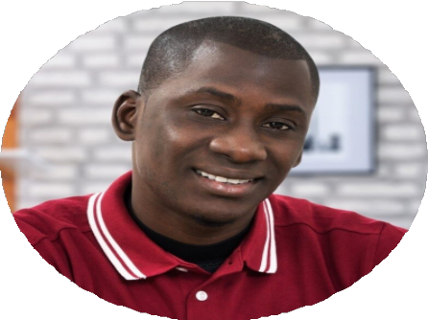
EDUCATION
Certiﬁcate in Culinary Arts
Le Cordon Bleu, Paris, France | May 2017

