C O N T A C T

ALEXANDER HUGHES
Freelance model
Versatile freelance model with expertise across multiple niches
Freelance model with 9 years of experience working in editorial, commercial, and runway modeling. Known for adaptability and building strong relationships with creative teams.

PROFESSIONAL EXPERIENCE

(123) 456-7890
June 2016 - Present
Freelance Model | Self-Employed | Austin, TX

email@example.com LinkedIn
Modeled in diverse campaigns, including ﬁtness, editorial, and promotional work, for clients such as Nike and regional startups
Built a portfolio that attracted repeat collaborations with photographers and local agencies

Austin, TX
June 2014 - June 2016
Commercial Model | Texas Creative Agency | Dallas, TX





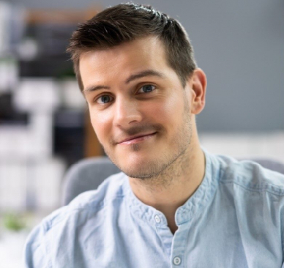
K E Y S K I L L S

Multi-niche modeling Independent client collaboration Portfolio building
Adaptability to styling Brand representation
Participated in product advertisements and brand campaigns, contributing to a 15% increase in client product awareness
Worked on independent projects to enhance modeling versatility and exposure

EDUCATION
Bachelor of Science (B.S.) in Marketing
University of Texas, Austin, TX | May 2014 Anticipated High School Graduation: June 2032

