Cameron Moore
Forensic Dentist

Forensic dentist with 10 years of experience in dental identiﬁcation and collaboration with law enforcement. Expert in maintaining detailed records and supporting investigations.

CONTACT
PROFESSIONAL EXPERIENCE

Forensic Dentist | Louisiana State Forensic Lab, New Orleans, LA
January 2015 - Present

(123) 456-7890
email@example.com LinkedIn
- Assisted in 75+ identiﬁcation cases in collaboration with medical examiners
- Maintained 100% accurate documentation for use in legal proceedings
- Delivered testimony in ﬁve court cases as an expert witness

City, ST 123
General Dentist | Crescent Dental Care, New Orleans, LA
June 2010 - December 2014

  - Practiced general dentistry while providing records to local authorities for forensic review

KEY SKILLS
- Dental forensics and identiﬁcation
- Detailed recordkeeping
- Legal collaboration and reporting

EDUCATION

Doctor of Dental Surgery (DDS)
Louisiana State University, Baton Rouge, LA | May 2010

Bachelor of Science in Biology
Tulane University, New Orleans, LA | May 2006

PROFESSIONAL DEVELOPMENT

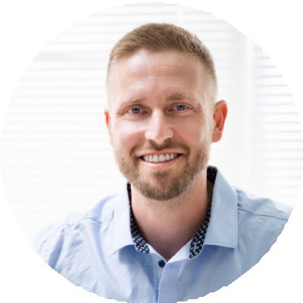




  - Certiﬁed Forensic Odontologist | ABFO | 2016

