Pat Thomas

Medical Doctor Geriatrics
Geriatric physician with 15 years of experience in elder care and chronic disease management
Known for improving quality of life for aging patients through preventive care, medication management, and interdisciplinary team leadership.

CONTACT
(000) 000-0000

PROFESSIONAL EXPERIENCE
Geriatric Physician | Evergreen Senior Care, Portland, OR February 2013 - Present

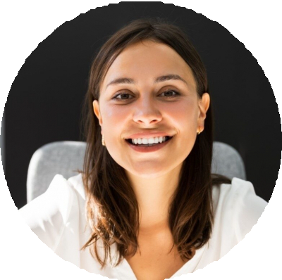



email@example.com City, ST

KEY SKILLS
Chronic illness management Geriatric assessments
Medication reconciliation Palliative care coordination Fall and safety prevention

EDUCATION
Doctor of Medicine (M.D.)
Oregon Health & Science University, Portland, OR
March 2007
Manage care for 200+ long-term patients with multiple chronic conditions
Reduced hospital readmissions by 22% through medication compliance programs
Led 6-person interdisciplinary team to coordinate holistic care plans

Internal Medicine Physician | Rosewood Medical, Portland, OR July 2008 - January 2013
Provided primary and preventive care for adult patients
Diagnosed and managed chronic conditions such as hypertension and diabetes
Initiated wellness programs that improved patient lifestyle adherence by 15%

