Jordan Miller
Bilingual customer service representative
Fluent in English and Spanish, Jordan has over six years of experience supporting customers in multilingual environments. Known for de-escalating sensitive issues and improving satisfaction across diverse customer bases.
PROFESSIONAL EXPERIENCE

C O N T A C T

(123) 456-7890

jordanmiller@email.com
January 2020 - Present
Bilingual Customer Service Representative | SoftServe Solutions | Miami, FL

Handle 75+ calls per day in English and Spanish, maintaining a 97% satisfaction rate
Developed Spanish-language FAQ resources, decreasing support requests by 20%
Mentor for bilingual staff training program





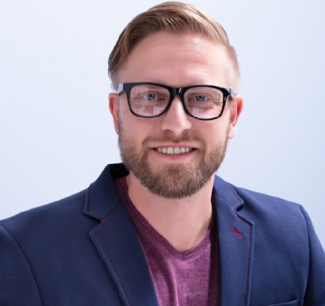
LinkedIn | Portfolio City, ST

K E Y S K I L L S

Bilingual support (Spanish/English) Escalation resolution
Multilingual CRM tools Training material localization Ticket tracking
August 2016 - January 2020
Customer Support Representative | GlobalComm | Miami, FL

Supported Latin American clients with billing and product questions Reduced complaint escalation rate by 25% with proactive communication Coordinated with the translation team for product rollouts

EDUCATION
Bachelor of Arts in Communications
Florida International University |

