Jamie Wilson
Academic Dentist
Academic dentist with 14 years of experience combining clinical practice and teaching.
Skilled at curriculum development and research mentoring.
PROFESSIONAL EXPERIENCE

C O N T A C T

(123) 456-7890
August 2012 - Present
Academic Dentist | University Dental School | Ann Arbor, MI

Taught operative dentistry and supervised 25+ students in clinical rotations Published ﬁve research papers on dental biomaterials and restoration techniques Developed updated course modules, improving exam pass rates by 15%

email@example.com LinkedIn
City, ST 123

K E Y S K I L L S

Dental education and curriculum design
Clinical supervision Research and publication
June 2009 - July 2012
Associate Dentist | Ann Arbor Dental Clinic | Ann Arbor, MI

Treated patients while assisting in student training programs Supported faculty research projects in dental materials testing

EDUCATION
Doctor of Dental Surgery (DDS)
University of Michigan, Ann Arbor, MI | - May 2009

Bachelor of Science in Chemistry
Michigan State University, East Lansing, MI | - May 2005





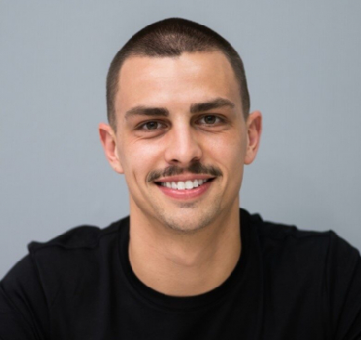

Fellowship in Dental Education | ADEA | 2014
PROFESSIONAL DEVELOPMENT

