Cameron Moore
Bank Staf Accountant
Bank staff accountant with four years of experience handling ﬁnancial reporting, reconciliations, and compliance tasks in the banking industry. Experienced in working with high-volume transaction environments and supporting internal audits.

CONTACT
(123) 456-7890

PROFESSIONAL EXPERIENCE

Bank Staff Accountant | Bank of the Carolinas, Charlotte, NC
March 2021 - Present

email@example.com Charlotte, NC 12345
- Prepare monthly reconciliations for deposit, loan, and investment accounts
- Support internal and external audit processes by providing requested documentation and analysis
- Generate quarterly compliance reports, ensuring adherence to banking regulations

KEY SKILLS

Accounting Associate | SouthState Bank, Charlotte, NC
June 2019 - February 2021

- Bank reconciliations
- Compliance reporting
- Financial statement preparation
- Loan account analysis
- Assisted in daily journal entries and account reconciliations
- Compiled weekly transaction summaries for management review
- Collaborated with auditors to address documentation needs and reduce compliance issues

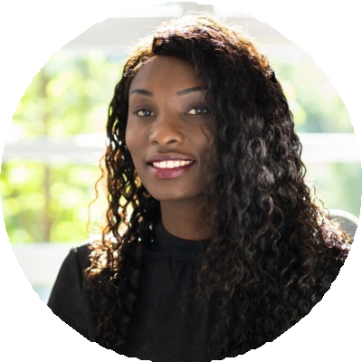



EDUCATION

Bachelor of Science in Accounting
University of North Carolina, Charlotte, NC | May 2019

PROFESSIONAL DEVELOPMENT
Certiﬁed Bank Auditor (CBA), Bank Administration Institute

