CASEY DAVIS
Entry level pharmacist resume

ABOUT ME

CONTACT
 (000) 000-0000
 cdavis@email.com  LinkedIn | Portfolio  Denver, CO 80202

KEY SKILLS
Drug interaction checks EMR documentation
Medication education
OTC product recommendations Prescription veriﬁcation
Sterile compounding
Newly licensed pharmacist ready to contribute to safe and efficient pharmacy care
Entry-level pharmacist with recent Pharm.D. and over 1,500 hours of
supervised clinical experience in both hospital and retail settings. Passionate about patient education, compliance, and quality assurance.

PROFESSIONAL EXPERIENCE
Pharmacy Intern
Denver General Hospital, Denver, CO | August 2022 - May 2024
Veriﬁed medication orders with preceptors for ER and ICU patients Participated in antimicrobial stewardship rounds
Pharmacy Intern
Walgreens Pharmacy, Aurora, CO | August 2021 - May 2022
Administered vaccinations and provided medication counseling under pharmacist supervision
Trained in insurance billing and medication prior authorization processing

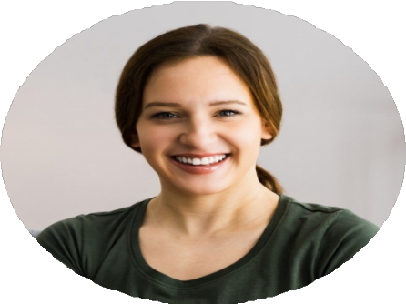
EDUCATION
Doctor of Pharmacy (Pharm.D.)
University of Colorado, Aurora, CO | May 2024

