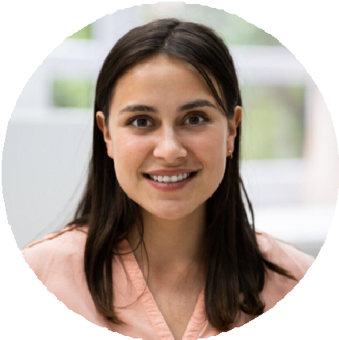




Cameron Moore
Computer Help Desk

Computer help desk specialist with extensive experience supporting desktop and mobile environments. Adept at software troubleshooting, hardware replacement, and system configuration.

PROFESSIONAL EXPERIENCE

Computer Help Desk Technician, Lenovo, Morrisville, NC
CONTACT
May 2017 – Present

Performed system configurations and upgrades for 500+ users annually Improved ticket response time from two to one day
KEY SKILLS

Bachelor of Science in Computer Science North Carolina State University, Raleigh, NC
May 2015
EDUCATION

(000) 000-0000

email@example.com LinkedIn | Portfolio Raleigh, NC 12345
Provided after-hours support during critical system outages

IT Support Assistant, SAS Institute, Cary, NC
June 2015 – April 2017

Installed and configured hardware for new hires
Assisted with migration to a new email platform, reducing downtime Supported remote employees via secure VPN

PROFESSIONAL DEVELOPMENT

CompTIA A+ Certification, CompTIA

Desktop support Hardware installation Software troubleshooting

