Rachel Morgan
L E G A L P E R S O N A L A S S I S T A N T

Organized legal personal assistant skilled in administrative and legal support
Five years of experience supporting attorneys with scheduling, documentation, and case preparation.

CONTACT
(123) 456-7890

PROFESSIONAL EXPERIENCE

Legal Personal Assistant | Morgan & Associates, Washington, D.C. | January 2020 – Present

email@example.com LinkedIn
Maintained detailed case ﬁles and prepared documents for court hearings, reducing preparation errors by 25%
Coordinated attorneys’ schedules to ensure deadlines were consistently met

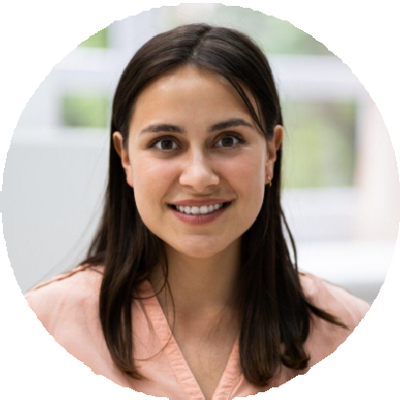




Washington, D.C.

KEY SKILLS
Legal documentation Calendar management Filing and archiving Communication
Time management

Administrative Assistant | Law Ofﬁce of David Brown, Washington, D.C. | May 2018
– December 2019

Assisted with client correspondence and ﬁling, improving ofﬁce organization and workﬂow efﬁciency

EDUCATION

Associate Degree in Paralegal Studies
George Mason University, Washington, D.C. | May 2018

