ISABELLA
RAMIREZ
Bilingual Personal Assistant

ABOUT ME

CONTACT
 (123) 456-7890
 email@example.com  LinkedIn
 Houston, TX

KEY SKILLS
Efficient bilingual personal assistant fluent in English and Spanish Five years of experience supporting executives and private clients, specializing in cross-cultural communication and task management.

PROFESSIONAL EXPERIENCE
Bilingual Personal Assistant
Private Client, Houston, TX | June 2020 - Present
Coordinated schedules and translated documents for international meetings, improving communication efﬁciency by 30%
Managed personal errands and travel itineraries across bilingual regions

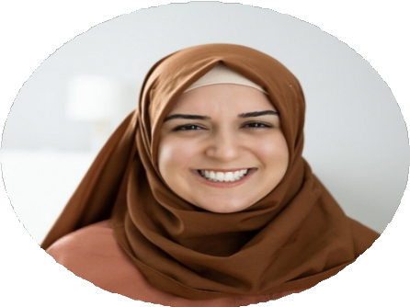
Multilingual communication Travel coordination Scheduling
Document translation Customer service
Customer Service Representative
Global Connect, Houston, TX | July 2018 - May 2020
Resolved customer inquiries in both English and Spanish, achieving a 95% satisfaction rate

EDUCATION
Bachelor of Arts in International Relations
University of Houston, Houston, TX | May 2018

