Jamie Wilson
Biology tutor
Enthusiastic biology tutor with four years of experience helping high school and college students understand complex biological concepts. Specializes in microbiology, cell structure, and genetics, with a strong record of improving academic outcomes through creative teaching.

CONTACT
(123) 456-7890

PROFESSIONAL EXPERIENCE

Biology Tutor | Science Scholars Academy, Denver, CO
August 2021 - Present

email@example.com City, ST 123
- Conduct one-on-one and group sessions covering AP Biology curriculum
- Created visual aids to simplify cell processes and molecular functions
- Helped students improve test performance by 22% over two semesters

KEY SKILLS

Lab Assistant | Denver Community College, Denver, CO
June 2019 - May 2021

- Anatomy knowledge
- Curriculum planning
- Assisted biology professors with lab preparation and data collection
- Supported 40+ students weekly during open lab sessions

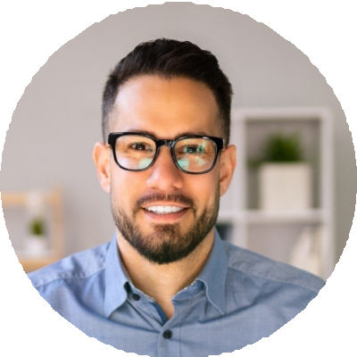



- Experiment explanation
- Lab report guidance
- Scientiﬁc writing

EDUCATION

Bachelor of Science in Biology
University of Colorado, Boulder, CO | May 2019

