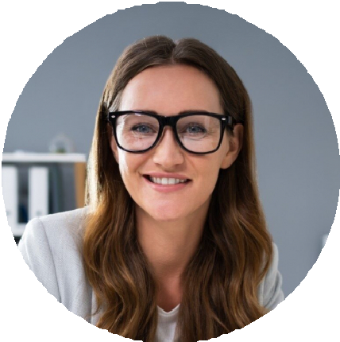




Certificate in Medical Office Technology Brookline Technical Institute, City, ST May 2018
Taylor Smith
Front Desk Specialist
Attentive and organized front desk specialist
Front desk specialist with 5 years of experience ensuring positive first impressions and supporting front-line operations in orthopedic and internal medicine practices.
PROFESSIONAL EXPERIENCE
Front Desk Specialist, Northfield Orthopedics, City, ST
February 2020 – Present

Maintain a steady workflow for 80+ daily patients and five orthopedic surgeons
Resolve patient concerns on arrival and provide accurate follow-up instructions
Assist with check-out and referral generation

Medical Receptionist, Blue Ridge Family Health, City, ST
June 2018 – January 2020

Supported front desk operations and managed appointment reminder system
EDUCATION

(123) 456-7890

taylor.smith@email.com City, ST 123
CONTACT

Reduced no-show rate by 15% through new call protocols
KEY SKILLS
Appointment scheduling Multi-line phone management Patient satisfaction initiatives Data entry and records Copay processing
Office supply tracking

