Sara Fields

Makeup Artist
Certified makeup artist with 6+ years of experience in bridal, editorial, and film production beauty. Expert in skin tone matching, HD makeup application, and special effects (SFX) techniques. Known for calm professionalism under tight set schedules, maintaining 5-star client satisfaction across 150+ annual clients, and increasing bridal bookings by 35% through targeted workshop programming and referral-driven client development.

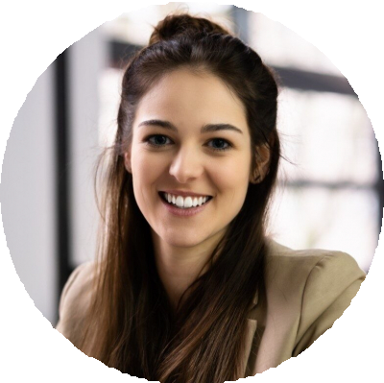




CONTACT
(000) 000-0000

email@example.com LinkedIn
Chicago, IL

KEY SKILLS
Bridal and special occasion makeup application
HD and airbrush makeup for ﬁlm and photography
SFX prosthetics and aging techniques
Skin tone matching and color correction
Editorial styling and fashion shoot collaboration
Contouring, highlighting, and facial sculpting
Cosmetic hygiene and sanitation compliance
Client consultation and mood board development
Time management for multi-client event days

EDUCATION
Diploma in Professional Makeup Artistry
Make-Up Designory (MUD), New
York, NY May 2020

PROFESSIONAL EXPERIENCE
Makeup Artist | Luxe Bridal & Beauty, Chicago, IL May 2019 - Present
- Complete full makeup services for 150+ clients per year across bridal, editorial, and special occasion bookings, maintaining consistent 5-star satisfaction rating across all platforms
- Led 12 bridal beauty workshops annually, increasing client booking volume by 35% year over year through hands-on education and referral conversion
- Partner with 10+ photographers on high-end editorial shoots, delivering looks that translate accurately for both print and digital publication
- Developed a signature bridal consultation process that reduced day-of revision requests by 40% and increased average booking value by 25% through upsell services
- Managed product inventory of 300+ SKUs, maintaining stock levels and reducing product waste by 20% through systematic ordering practices
- Trained 2 junior makeup artists on client consultation techniques and HD application standards, both achieving independent client bookings within 3 months

Assistant Makeup Artist | Windy City Productions, Chicago, IL May 2017 - April 2019
- Provided on-set makeup support for 20+ local television commercials and independent film shoots, maintaining continuity across multi-day productions
- Organized and sanitized equipment between client sessions, maintaining compliance with Illinois Department of Health sanitation standards on all productions
- Shadowed senior artists across SFX, editorial, and film applications on 15+ productions, developing portfolio across 8 distinct makeup specializations
- Assisted in creating SFX looks for 3 short film projects, contributing to period-accurate and genre-appropriate character designs

CERTIFICATIONS
Certified Makeup Artist (CMA), Make-Up Artists Association | May 2017

