Sophia Williams

Pastry Chef


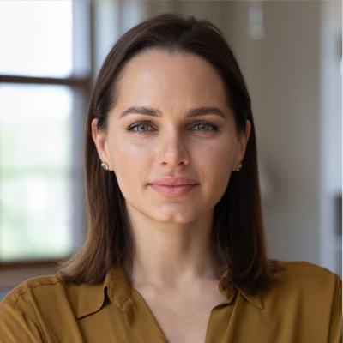

Location
New York, NY 10001

Phone
(123) 456-7890

Email
email@example.com

Website
Linkedin

Education
Johnson & Wales University, Providence, RI
| May 2015
Bachelor of Arts Baking and Pastry Arts
Le Cordon Bleu, Paris, France
| December 2012 Diploma Patisserie

Key Skills
Advanced pastry techniques and dessert menu development
Chocolate and sugar artistry and showpiece construction
Bread and viennoiserie production and laminated dough
Plated dessert design and presentation standards
Pastry kitchen team leadership and training (10+ staff)
Head Pastry Chef with 8+ Years Driving Dessert Revenue and Team Excellence in Hotel and Patisserie Settings
Creative and results-driven pastry chef with over eight years of experience in high-end hotels and artisan patisseries. Skilled in developing seasonal dessert menus, managing production teams of 10+, and delivering measurable improvements in revenue, food cost, and team performance. Increased dessert sales by 35% and reduced pastry department food costs by 18% through innovative menu design and disciplined ingredient management. Certiﬁed Executive Pastry Chef with training from Johnson & Wales and Le Cordon Bleu Paris.

Professional Experience
Head Pastry Chef , Grandview Hotel | New York, NY
June 2018 - Present

- Develop and launch new seasonal dessert menus four times annually, with menu refreshes contributing to a 35% increase in dessert sales and a 20% overall increase in restaurant revenue over a ﬁve-year tenure
- Lead and mentor a team of 10 pastry cooks and assistants, implementing structured training programs that improved team efﬁciency by 25% and reduced staff turnover by 15%
- Optimize ingredient usage and production scheduling to reduce pastry department food costs by 18% annually, generating approximately $24,000 in savings without compromising product quality
- Collaborate with executive chefs and event planners on custom dessert designs for high-proﬁle banquets and galas serving up to 500 guests, consistently earning commendations from event coordinators

Pastry Chef de Partie , Sweet Delights Patisserie | Providence, RI
January 2015 - May 2018

- Contributed to innovative pastry and dessert offerings that earned the patisserie recognition as 'Best Desserts in Providence' for two consecutive years in regional food industry awards
- Managed daily production of pastries, cakes, and confections for a shop serving 300+ customers daily, maintaining strict consistency and quality standards across all product lines
- Trained junior pastry staff on techniques and equipment operation, improving overall kitchen productivity by 20% and reducing batch preparation errors
- Monitored ingredient inventory and coordinated supplier deliveries, reducing stock shortages by 30% through improved par-level management and advance ordering protocols

Certiﬁcations
- Certiﬁed Executive Pastry Chef (CEPC) , American Culinary Federation, November 2019
- Advanced Chocolate and Sugar Showpiece Workshop , The French Pastry School, September 2018
- Artisanal Bread Baking Course , San Francisco Baking Institute, January 2016

