Olivia Harris

Arts and Crafts Camp Counselor

CONTACT
Arts and crafts camp counselor with five years of experience designing creative programming for children at Blue Ridge Creativity Camp. Led 10+ weekly hands-on projects for groups of 20+ campers, increasing participation by 30%,
and organized an end-of-session art show attended by 100+ parents. Combines creative curriculum design with structured group supervision and child safety management to deliver engaging, high-quality arts programming for a range of ages and skill levels.

PROFESSIONAL EXPERIENCE

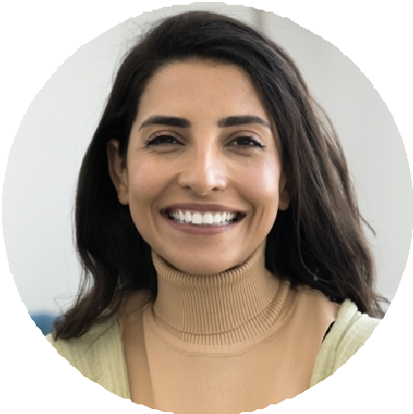




(123) 456-7890

email@example.com LinkedIn
Asheville, NC

KEY SKILLS
Multi-medium arts and crafts project design (painting, sculpture, collage, printmaking)
Weekly curriculum planning for hands-on art sessions across multiple age groups
Group supervision for 20+ campers during hands-on art activities
Art supply management, preparation, and workspace safety maintenance
End-of-session art exhibition planning and family event coordination
Camper creativity encouragement and skill-appropriate project differentiation

EDUCATION
Bachelor of Fine Arts (B.F.A.)
University of North Carolina, Chapel Hill, NC
May 2019
Arts and Crafts Camp Counselor, Blue Ridge Creativity Camp, Asheville, NC
June 2021

Designed and led 10+ weekly arts and crafts projects for groups of 20+ campers, covering painting, sculpture, collage, and printmaking techniques, increasing overall session participation by 30% through format and medium variety
Supervised groups of 20+ campers during hands-on art sessions, maintaining workspace safety standards, managing material access, and monitoring for equipment hazards throughout each activity
Organized an end-of-session art show displaying camper work to 100+ family members, managing gallery layout, artwork labeling, and family invitation logistics across three consecutive annual shows

Camp Volunteer, Community Arts Program, Asheville, NC
August 2019 – June 2021

Assisted art instructors in teaching basic painting and sculpting techniques to groups of 10-15 youth participants during weekly community art sessions
Helped prepare workspace for each session by setting up materials, organizing supply stations, and ensuring safe and clean working conditions before participant arrival
Managed material distribution and cleanup during hands-on sessions, maintaining supply organization and safe disposal of materials according to program safety guidelines

CERTIFICATIONS
Leave No Trace Trainer Certification | Leave No Trace Center for Outdoor Ethics | Current

