John Bergsen

Health Care Chief Executive Officer

Health care CEO with expertise in strategic leadership and financial management
Senior health care executive with over 15 years of experience leading large-scale hospital systems and pharmaceutical organizations. Expertise in strategic planning, financial oversight, regulatory compliance, and stakeholder engagement. Proven track record of driving 30% revenue growth, improving patient satisfaction by 35%, and building high-performing leadership teams. Skilled at navigating complex regulatory environments to deliver sustainable financial and clinical outcomes across diverse health care settings.

Contact information
(123) 456-7890

email@example.com LinkedIn
New York, NY

Education
DOCTOR OF MEDICINE (MD) | JOHNS HOPKINS UNIVERSITY SCHOOL OF MEDICINE, BALTIMORE, MD
MASTER OF HEALTH ADMINISTRATION (MHA) | UNIVERSITY OF NORTH CAROLINA, CHAPEL HILL, NC
MASTER OF BUSINESS ADMINISTRATION (MBA) | HEALTH CARE MANAGEMENT HARVARD BUSINESS SCHOOL, BOSTON, MA

Professional experience
CHIEF EXECUTIVE OFFICER | GLOBAL HEALTH INNOVATIONS, NEW YORK, NY | JANUARY 2017 - PRESENT

Led enterprise-wide strategic transformation resulting in 30% revenue growth over ﬁve years, expanding into three new regional markets and diversifying service lines across hospital and pharmaceutical verticals.
Managed and developed a workforce of 500+ employees across clinical and administrative functions, implementing leadership development programs that improved retention by 25% and reduced turnover costs by
$2.1 million annually.
Directed a two-year operational efﬁciency initiative across all business units, achieving 20% improvement in operational efﬁciency and reducing operational costs by 15% through process standardization and technology modernization.
Cultivated strategic partnerships with 15+ major health care providers and regulatory agencies, resulting in 35% improvement in patient satisfaction scores and securing three new institutional contracts valued at $45 million.
Oversaw a $750 million annual budget, implementing zero-based budgeting principles that identiﬁed $22 million in savings while maintaining full compliance with CMS and Joint Commission standards.

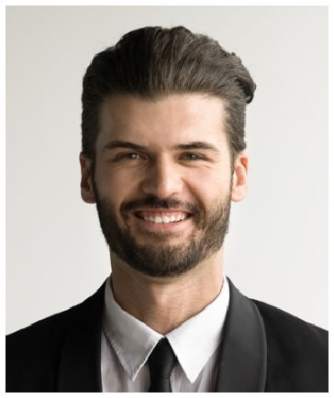




Key skills
Strategic planning and market expansion
Financial management and P&L oversight
Health care operations management
Regulatory compliance and risk mitigation
Stakeholder and board relations
Change management and organizational transformation
Quality assurance and patient outcomes improvement
VICE PRESIDENT OF OPERATIONS | HEALTHCORP SOLUTIONS, ANYTOWN, USA | JUNE 2012 - DECEMBER 2016

Led the operations division for four years, overseeing 200 staff members across six regional ofﬁces and improving operational efﬁciency by 25% through standardized workﬂows and enterprise technology adoption.
Managed a $500 million operating budget, achieving full ﬁnancial compliance and reducing audit ﬁndings by 40% through enhanced internal control frameworks and rigorous monthly performance reviews.
Cultivated relationships with key investors and regulatory stakeholders over three years, increasing investor satisfaction scores by 15% and securing an additional $75 million in capital commitments.

Certifications
Fellow of the American College of Healthcare Executives (FACHE), American College of Healthcare Executives
Certiﬁed Professional in Healthcare Quality (CPHQ), National Association for Healthcare Quality

