Sophia Martinez

Biologist

Dedicated Biologist with Extensive Research Experience in Molecular Biology and Ecology
Biologist with over 7 years of experience conducting research in molecular biology and ecology. Skilled in laboratory techniques, data analysis, and field research. Proven ability to lead research projects, publish findings in peer-reviewed journals, and present at scientific conferences. Committed to advancing scientific knowledge and environmental conservation.

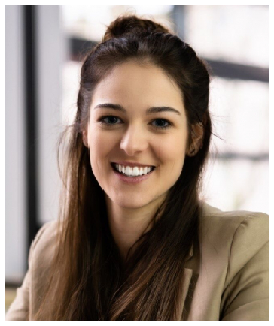




Contact information

(555) 987-6543

sophia.martinez@example.com LinkedIn
San Francisco, CA

Education
MASTER OF SCIENCE IN BIOLOGY
| STATE UNIVERSITY, SAN FRANCISCO, CA | 2015
BACHELOR OF SCIENCE IN ENVIRONMENTAL SCIENCE | CITY COLLEGE, LOS ANGELES, CA | 2013

Key skills
Molecular biology techniques (PCR, qPCR, gel electrophoresis)
Data analysis (R, Python, SPSS) Field research and data collection
Experimental design and methodology
Scientiﬁc writing and publication Project management
Team leadership and collaboration
Environmental impact assessment Laboratory safety and compliance Grant writing and fundraising

Professional experience
SENIOR BIOLOGIST | ECOGEN RESEARCH INSTITUTE, SAN FRANCISCO, CA | JUNE 2018 - PRESENT

Led a research team of 5 scientists over the past 5 years, studying the genetic diversity of endangered plant species, resulting in the identiﬁcation of 3 new genetic markers.
Published 8 peer-reviewed articles in reputable scientiﬁc journals during this period.
Secured $500,000 in research grants through successful grant proposals over a three-year span.
Presented ﬁndings at 10 national and international conferences, enhancing the institute’s reputation.
Implemented new laboratory protocols, increasing efﬁciency by 20% and reducing errors by 15%.

RESEARCH BIOLOGIST | BIOTECH LABS, SACRAMENTO, CA | MAY 2015 - MAY 2018

Conducted molecular biology experiments for three years, focusing on gene expression in response to environmental stressors.
Collected and analyzed data from over 200 ﬁeld samples, contributing to a larger project on ecosystem resilience.
Collaborated with a multidisciplinary team over a two-year project to develop a novel method for DNA extraction, reducing processing time by 25%.
Trained 10 laboratory assistants in proper laboratory techniques and safety protocols over an 18-month period.
Assisted in writing grant proposals, contributing to the acquisition of
$200,000 in funding within one year.

Certifications
Certiﬁed Wildlife Biologist, The Wildlife Society | 2016
First Aid and CPR Certiﬁed, American Red Cross | Current

