KAREN THOMAS
Law And Legal

ABOUT ME

CONTACT INFORMATION

 (919) 555-0142
 m.quintero@example.com  Raleigh, NC 12345

KEY SKILLS
- Relativity / RelativityOne
- Everlaw and Concordance
- CompuLaw and iManage
- Westlaw and Lexis+
- E-discovery and Bates production
- Deposition and trial prep
- Cite-checking (Bluebook)
- Spanish (conversational)
Litigation paralegal with 7 years supporting complex civil and commercial cases in mid-size firms. Strong on e-discovery workflows, trial prep, and managing high-volume document review. Known by attorneys for catching missed exhibit numbers before filing deadlines.

PROFESSIONAL EXPERIENCE
Senior Litigation Paralegal
Hartwell & Brennan LLP, Raleigh, NC | 2021 - Present
  - Manage discovery on 12-15 active commercial litigation matters, including a contract dispute that recovered $2.4M for the client at mediation.
  - Built a Relativity review workﬂow with the e-discovery vendor that cut ﬁrst-pass review time by roughly a third on document-heavy matters.
  - Coordinate trial logistics with three trial teams: witness binders, deposition designations, and exhibit lists for state and federal court.
  - Train two junior paralegals on cite-checking and Bluebook formatting; serve as backup notary for the litigation group.
Litigation Paralegal
Owsley Marlow PA, Durham, NC | 2018 - 2021
  - Supported two partners on insurance defense matters across NC and SC trial courts.
  - Drafted subpoenas, deposition notices, and discovery responses; tracked deadlines in CompuLaw for an average caseload of 40 open ﬁles.
  - Indexed and Bates-stamped over 180,000 pages of medical and employment records during a multi-plaintiff wage-and-hour case.
  - Coordinated with court reporters and videographers for 60+ depositions per year.

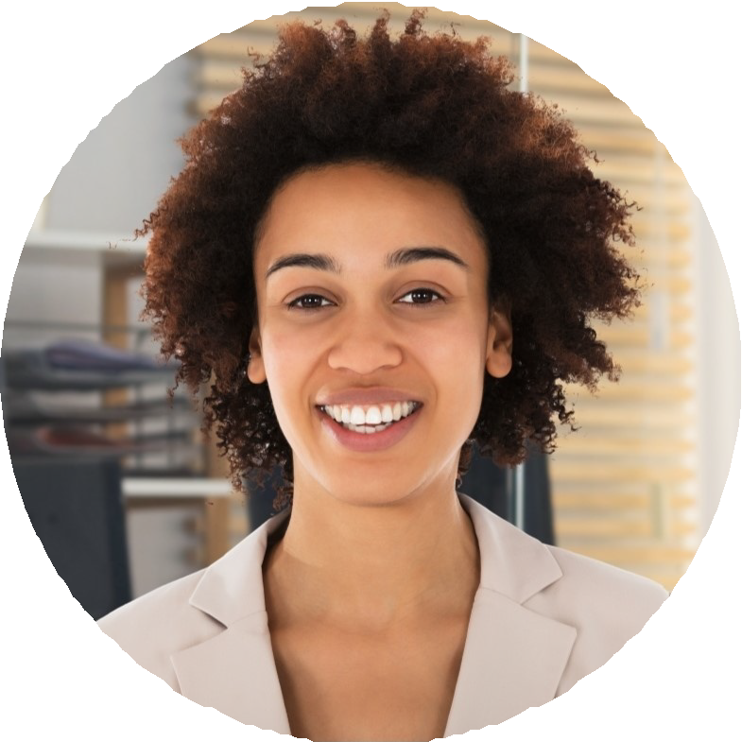
Paralegal
Cardinal Legal Services, Cary, NC | 2017 - 2018
Handled intake for personal injury matters, screening roughly 15 potential client calls a day.
Drafted demand letters and tracked medical lien negotiations with hospital systems.
Maintained client ﬁles in Clio and prepared monthly status reports for two attorneys.

EDUCATION
Paralegal Certiﬁcate, Meredith College, 2017

B.A. in English, University of North Carolina at Greensboro, 2016 NC Notary Public, commissioned 2019

