YELENA PETROSYAN

Master stylist and color educator with 16 years of experience, including 7 years as the top revenue producer at a high-end Scottsdale salon. Specialize in extensions, corrective color, and platinum work. Teach hands-on classes for Great Lengths and run a private mentorship program for stylists transitioning to booth rental.

Location
Scottsdale, AZ

Phone
(480) 217-6603

Email
yelena.petrosyan@email.com

Website
Linkedin.com/in/yelenapetrosyan

Education
Toni & Guy Hairdressing Academy
| May 2009 Cosmetology Diploma

Key Skills
Hand-tied and tape-in extensions (Great Lengths, Bellami)
Color correction (banded blondes, box-dye removal, fashion fades)
Platinum and double-process blonding
Stylist mentorship and team education
Booth-rental business coaching Editorial and on-set styling

Professional Experience
Master Stylist & Salon Educator , Ravel Hair Atelier | Scottsdale, AZ
March 2017 - Present

Top revenue producer for 7 consecutive years, generating $268,000 in service sales in 2023.
Maintain a closed book of 410 clients with a 14-week average lifetime, sees clients on a 5 or 6-week rotation only.
Lead in-salon education for a team of 11 stylists, including monthly cutting labs and corrective-color case reviews.
Manage extension program (Great Lengths and Bellami hand-tied), averaging 14 install or move-up appointments per month at $1,200-$2,400 each.
Built the salon's consultation framework that lifted new-client rebook from 51% to 73% over 18 months.

Senior Stylist, Verbena Salon Group | Tempe, AZ
July 2012 - February 2017

Promoted from stylist to senior level in year three based on rebook rate and retail performance.
Specialized in corrective color, took roughly 30% of the salon's color-correction referrals.
Trained four assistants through the salon's apprenticeship program, three are still actively working in the industry.
Hit Wella Master Color Expert certiﬁcation in 2016.

Stylist , Indigo Salon | Chandler, AZ
August 2009 - June 2012

Started as a fresh license, built a 180-client book in 26 months on a commission ﬂoor.
Took on platinum and double-process clients as senior stylists referred them out.
Picked up runway and photo-shoot styling work for a local fashion magazine, 9 published features.
Carried the highest retail dollars per ticket on the team for 2011.

Certiﬁcations


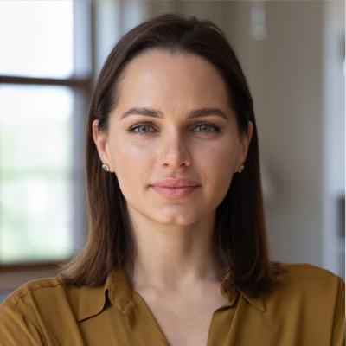
- Wella Master Color Expert, October 2016
- Great Lengths Master Educator, December 2019
- Bellami Professional Certiﬁed, April 2021

