PRIYA
LAKSHMAN, PT, DPT, OCS
Physical Therapist

C O N T A C T I N F O R M A T I O N

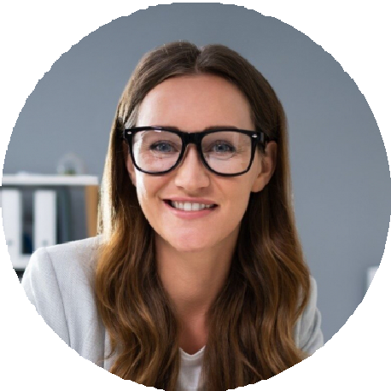




(608) 555-0173

priya.lakshman@example.com linkedin.com/in/priyalakshman Madison, WI

E D U C A T I O N

Doctor of Physical Therapy
University of Wisconsin-Madison, 2019

B.S. Biology
Marquette University, 2016

Orthopedic Clinical Specialist (OCS)
2021

Dry Needling Levels 1 & 2
Myopain Seminars

S K I L L S

Sports and orthopedic rehabilitation Dry needling (Level 2)
Running gait analysis Throwing athlete rehab
Manual therapy (Maitland, Mulligan) Clinical instruction (CCIP)
Epic and WebPT
Outcome tracking (FOTO, LEFS, DASH)
Patient-centered goal setting

A B O U T M E
Outpatient orthopedic PT with 6 years of mixed sports medicine and chronic pain caseload experience. Comfortable running point on complex post-op patients and the go-to person at my clinic for patients who have plateaued elsewhere.

E X P E R I E N C E
Physical Therapist III
Lakeside Orthopedic Therapy | Madison, WI | 2022-Present
Maintain caseload of around 60 patient visits per week with 92% patient satisfaction on post-discharge surveys.
Specialize in running and overhead athlete rehab; built clinic's return-to-throw program for baseball players.
Trained 3 staff PTs on dry needling protocols after completing Level 2 certification.
Reduced average patient cancellations by writing a same-day reschedule script the front desk now uses.
Sit in on monthly case conferences with referring orthopedic surgeons at two partner practices.
Physical Therapist
Heartland Sports Rehab | Rockford, IL | 2019-2022
Treated 12-15 patients per day in a high-volume outpatient sports medicine setting.
Earned OCS certification while working full time, passing on first attempt in 2021.
Served as clinical instructor for 5 DPT students from two regional programs.
Created intake screening form for cervicogenic headache patients still used at the clinic.

