MARISOL TANAKA
2D and 3D animator with six years of broadcast, game cinematic, and explainer work. Strong in character performance, layout, and pipeline tooling across Maya, Blender, and After Effects. Ship on tight episodic schedules and direct junior animators through reviews.

PROFESSIONAL EXPERIENCE

C O N T A C T

(503) 412-7788

marisol.tanaka@example.com Linkedin.com/in/marisoltanaka Portland, OR
April 2021
Animator | Foxtail Picture Co. | Portland, OR

Animate 14 to 22 shots per episode for a streaming kids series, hitting a weekly quota of 4.2 ﬁnal-approved seconds with under one revision per shot on average.
Built a reusable rig library for background characters that cut secondary-cast setup from two days to about four hours.
Lead dailies for a pod of three junior animators, giving notes on weight, arcs, and lip sync.
Partner with the layout supervisor to lock blocking before in-betweens, reducing late-stage reshoots across the season.
September 2019 - March 2021
Junior Animator | Greyharbor Studios | Eugene, OR





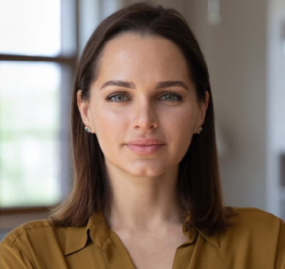
K E Y S K I L L S

Maya, Blender, Toon Boom Harmony, After Effects, ZBrush
Character animation, lip sync, layout, blocking, polish
Python and MEL scripting, ShotGrid, Perforce, Git
Dailies leadership, junior mentoring, director collaboration
Owned secondary character animation on two seasons of an adult animated
comedy, averaging 38 shots per episode.
Cleaned up keyframes from senior animators and handled facial pass on dialogue-heavy scenes.
Wrote a small MEL script to batch-export playblasts for review, saving the team several hours each Friday.
Took feedback from the director and supervisor across three to four review rounds per shot without slipping the schedule.

EDUCATION
BFA
Animation, Paciﬁc Northwest College of Art | February 2019

