ELENA SOKOLOVA

Electrical engineer with 6 years across power electronics and embedded ﬁrmware for battery storage products. Took two converter platforms from breadboard to UL listing.
Strong on cross-discipline work with mechanical and ﬁrmware teams.

Professional Experience

Contact Information
Electrical Engineer | February 2022 - Present
Kestrel Energy Systems, Salt Lake City, UT

(801) 555-0167
elena.sokolova@example.c om
Linkedin.com/in/elena-sokolova-eng
Salt Lake City, UT
Designed the gate driver and protection board for a 15 kW bidirectional inverter; passed UL 1741 SA on ﬁrst submission.
Reduced standby losses on the auxiliary supply by about 22% through a redesigned ﬂyback stage.
Owned the BOM for two product variants and worked with sourcing to qualify a second magnetics vendor after a 14-week lead time spike.
Wrote the EMC test plan and supported three pre-compliance trips at a Salt Lake lab.


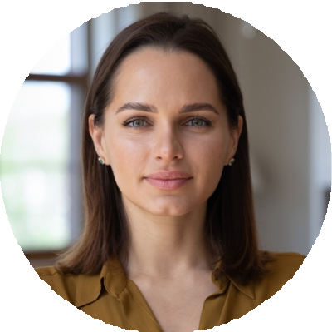





Education

B.S. Electrical Engineering Colorado School of Mines May 2018
Coursera Specialization: Power Electronics (University of Colorado Boulder), 2021

Key Skills

Altium Designer, KiCad LTspice, PLECS
Embedded C, STM32 / NXP
Power electronics (DC-DC, inverter)
UL 1741, IEEE 1547, IEC 61000
Oscilloscope, LCR, network analyzer
Python for test automation DFMEA, design reviews
Hardware Engineer | August 2019 - January 2022
Tessera Microgrid, Boulder, CO

Laid out 4 and 6 layer mixed-signal PCBs in Altium for grid-tied monitoring units.
Debugged a recurring CAN bus error that had been open for nine months and root-caused it to a ground loop in the test ﬁxture.
Built a Python-based regression harness that cut board bring-up time from a full day to under two hours.
Wrote ﬁrmware patches in C for the STM32 monitoring MCU when the ﬁrmware team was capacity-constrained.

Test Engineer | June 2018 - July 2019
Veridian Powertrain, Loveland, CO

Ran HALT and thermal cycling on traction inverter samples for a Tier 1 automotive customer.
Authored 11 test reports that fed the PPAP submission for the customer's 2019 model year program.
Maintained the lab's calibration log and brought the lab back into ISO 17025 compliance after an internal audit ﬁnding.

