HELENA
BROCKWELL
CPA with six years spanning Big Four assurance and SaaS industry accounting. Owns close, technical memos, and SOX walkthroughs, with recent experience standing up new processes after a Series C raise.

CONTACT INFORMATION
PROFESSIONAL EXPERIENCE

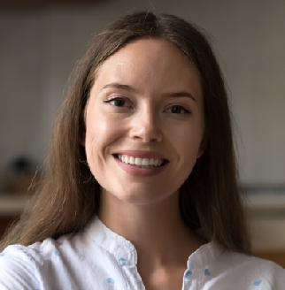
 (801) 555-0173
 helena.brockwell@example.com  Linkedin.com/in/helenabrockwell  Salt Lake City, UT

EDUCATION

M.Acc. University of Utah May 2018

B.S. in Accounting University of Utah May 2017
CPA, Utah (Licensed 2020)

KEY SKILLS

- NetSuite, FloQast, Carta, Stripe revenue reporting
- ASC 606, ASC 842, ASC 718 stock
comp
- SOX walkthroughs and control design
- Audit liaison, technical memo drafting
- Excel power user, SQL (basic)
SENIOR ACCOUNTANT | QUARTERGLASS SOFTWARE, SALT LAKE CITY, UT OCTOBER 2022 – PRESENT
Close the books for a $28.4M ARR SaaS business in 5 business days, down from 9 when I joined
Built the ASC 606 revenue policy and bookings-to-revenue waterfall now used by FP&A for forecasting
Reviewed staff accountant work on AR, AP, and prepaid schedules; mentored two new hires through their ﬁrst close
Partnered with external auditors on the ﬁrst PCAOB-style review post-Series C, no material adjustments
Implemented FloQast for reconciliations, reducing missing sign-offs from roughly a quarter of accounts to under 5%

AUDIT SENIOR | MARSTON & HALE LLP, DENVER, CO AUGUST 2022 – SEPTEMBER 2022
Led ﬁeldwork on ﬁve public and three private engagements in tech and healthcare
Drafted ASC 842 transition memos for three clients adopting in the same ﬁscal year
Reviewed control walkthroughs and test-of-controls workpapers for a SOX accelerated ﬁler

AUDIT ASSOCIATE | MARSTON & HALE LLP, DENVER, CO JUNE 2018 – JULY 2022
Executed substantive testing across revenue, cash, and inventory cycles Built and maintained client lead schedules in CaseWare
Promoted to senior six months ahead of standard track

