MARCUS DEWITT
LCSW-S

Clinical director with 16 years across community mental health, hospital social work, and program leadership. Built and scaled three integrated behavioral health programs serving 4,000+ patients annually. Approved clinical supervisor for LMSW licensure in Florida.

Contact Information

(813) 555-0142
marcus.dewitt@example.co m
Linkedin.com/in/marcusdewitt Tampa, FL

Education

MSW in Clinical Concentration Tulane University May 2008

BSW
University of South Florida May 2006

Certiﬁcate in Healthcare Leadership, USF Muma College of Business, 2019

Key Skills
Professional Experience

Director of Behavioral Health | February 2020 - Present
Gulfstream Health Network, Tampa, FL

Lead department of 34 clinicians and 6 care coordinators across 5 clinic sites; oversee $4.2M annual program budget.
Launched same-day behavioral health access program that cut average wait time from 23 days to 4 days within the ﬁrst year.
Negotiated value-based contract with regional Medicaid MCO covering 11,200 attributed members.
Chair quality committee that reduced 30-day psychiatric readmissions by roughly one-ﬁfth over two reporting cycles.
Mentor 4 mid-career clinicians toward LCSW-S supervisor designation.

Clinical Program Manager | August 2016 - January 2020
Harborlight Behavioral Services, St. Petersburg, FL

Managed adult outpatient program with 12 therapists and a combined caseload of about 780 active clients.
Rewrote crisis stabilization workﬂow, reducing average length of stay in the CSU from 5.2 to 3.6 days.
Wrote and won two SAMHSA grants totaling $1.6M for SUD and co-occurring disorders work.
Built supervision curriculum used by 9 LMSWs to complete licensure hours on time.


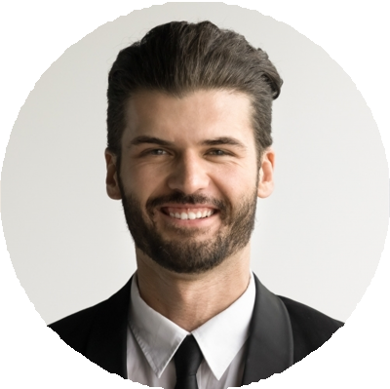




Behavioral health program design
Value-based care and Medicaid MCO contracting
Grant writing (SAMHSA, HRSA) Crisis stabilization workﬂow design Clinical supervision (LCSW-S) Budget management ($4M+)
Epic, Cerner, and Welligent EHRs
Quality improvement and PDSA cycles
Hospital ethics and palliative consults
Senior Clinical Social Worker | June 2012 - July 2016
Sunridge Memorial Hospital, Sarasota, FL

Provided complex discharge planning across ICU, oncology, and trauma units; carried 30 to 40 active patients weekly.
Led hospital response to two mass-casualty events, coordinating family reuniﬁcation and bereavement support.
Co-designed palliative care consult workﬂow now used hospital-wide. Precepted 11 MSW interns over four academic years.

Certifications

LCSW-S, Florida Board of Clinical Social Work, License #SW-14029

