JAYLEN BROOKS
Recent BFA graduate with strong training in modern, jazz, and hip-hop and growing credits in regional and university productions. Quick study with reliable retention of choreography and a flexible movement range. Seeking apprentice or trainee work with a contemporary company or commercial agency.

PROFESSIONAL EXPERIENCE

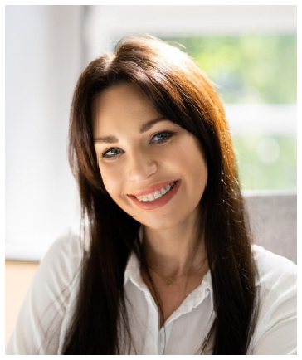





CONTACT
(267) 884-2031

jaylen.brooks@example.com linkedin.com/in/jaylenbrooks Philadelphia, PA

EDUCATION
BFA IN DANCE | TEMPLE UNIVERSITY | FEBRUARY 2024
ALVIN AILEY SUMMER INTENSIVE | MARCH 2022 - FEBRUARY 2023
HUBBARD STREET PRO WORKSHOP | FEBRUARY 2024

KEY SKILLS
Modern (Horton, Limón) Jazz and commercial
Hip-hop (hip-hop foundations, house basics)
Ballet through Intermediate Partnering basics Improvisation and composition
Choreography for small ensembles Social media content collaboration
DANCER | COBALT STEP COLLECTIVE, PHILADELPHIA, PA | SEPTEMBER 2021 - PRESENT

Cast as ensemble dancer in three works for the company's spring and fall showcases, performing 14 shows across both runs.
Picked up two understudy tracks during the spring program and went on for a featured solo with two days notice.
Helped teach Saturday community class for teens, averaging 22 students.
Assist on social media content shoots, including reels that reached over 40k views.

STUDENT DANCER | TEMPLE UNIVERSITY DANCE DEPARTMENT, PHILADELPHIA, PA | NOVEMBER 2019 - APRIL 2020

Performed in eight faculty and guest choreographer works across four years, including a piece by Camille A. Brown alumna Tanya Ortega.
Selected for senior thesis showcase as one of six choreographers and presented a 12-minute group work.
Served as rehearsal director for two undergraduate pieces, leading clean-up rehearsals and spacing calls.

APPRENTICE DANCER | HOLLOW LIGHT DANCE PROJECT, SEATTLE, WA | FEBRUARY 2018 - FEBRUARY 2021

Joined four-person apprentice cohort selected from 180 audition submissions.
Understudied principal roles in two full evening works and performed in 12 mainstage shows per season.
Taught company technique class for community workshop series, averaging 18 students per session.

