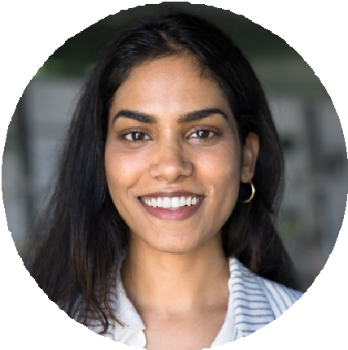





DEVON AKHTAR

Recent SCAD animation graduate focused on 3D character performance and motion graphics. Comfortable taking notes, iterating fast, and learning new rigs.
Looking for a junior animator seat on an episodic or game cinematic team.

PROFESSIONAL EXPERIENCE

Animation Intern, Lumen Lantern Animation, Savannah, GA
CONTACT
June 2024

Animated 11 background-character shots for an indie short, two of which made the final cut.
KEY SKILLS

BFA
Animation, Savannah College of Art and Design
February 2019
EDUCATION

(912) 555-0143

devon.akhtar@example.com Linkedin.com/in/devonakhtar Savannah, GA
Assisted senior animators with blocking passes and reference video shoots.
Logged daily progress in ShotGrid and presented work in twice-weekly review.
Helped clean up rig issues by filing 27 documented bug tickets with reproduction steps.

Freelance Motion Designer, Self-employed, Remote
June 2023 – March 2021

Built short social-media animations for three local restaurants and a podcast intro.
Delivered six to ten second loops in After Effects, usually within a 48-hour turnaround.
Handled client feedback and revision rounds directly over email and Loom.

Maya, Blender, After Effects, Photoshop, Premiere
Character blocking, polish, lip sync basics
Reference acting, thumbnail planning, dope sheets
ShotGrid, Frame.io, Git LFS

