Daniel Jackson
Personal Trainer

A B O U T M E

C O N TA C T I N F O R M AT I O N
Master trainer with 17 years across commercial gyms, private studios, and online coaching. Built and sold a six-trainer studio in 2022. Currently lead a hybrid in-person and online coaching practice, run continuing education for two certifying bodies, and consult for boutique gyms on programming and trainer development.

(503) 555-0119

marcus.vandeberg@example. com

Portland, OR 12345

E D U C AT I O N

M.S. Exercise Physiology, Oregon State University, 2013

B.S. Kinesiology, Portland State University, 2010

NSCA CSCS (2011) and CPT
(recertiﬁed 2024)

P R O F E S S I O N A L E X P E R I E N C E

OWNER AND HEAD COACH | VANDEBERG STRENGTH METHOD, PORTLAND, OR
2022 - PRESENT

Run a hybrid practice of 22 in-person and 41 online clients with annual revenue around $312,000 working solo with one part-time admin.
Designed the 16-week Method curriculum now licensed to 7 afﬁliate gyms across the Paciﬁc Northwest.
Coach 3 nationally ranked masters powerlifters, including 2 USAPL meet podium ﬁnishers in 2023.
Deliver 6-8 paid weekend workshops per year on assessment and programming, averaging 24 attendees per workshop.
Built a content library on YouTube and Substack with 41,000 combined subscribers as the studio's primary lead source.




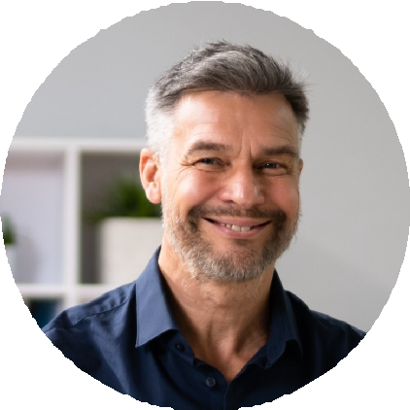
StrongFirst Certiﬁed SFG Level II

USAW Level 1 Sports Performance Coach

K E Y S K I L L S

Studio ownership and P&L Trainer hiring and mentorship
Programming for masters and competitive lifters
Continuing-education curriculum design
Hybrid in-person and online coaching delivery
Public speaking and workshop instruction
Afﬁliate licensing and partnerships
Content marketing (YouTube, Substack)
Post-rehab coordination with clinicians
Business sale and transition
CO-FOUNDER AND DIRECTOR OF COACHING | STUMPTOWN PERFORMANCE STUDIO, PORTLAND, OR
2017 - 2022

Co-founded a 6-trainer private studio; grew membership from 0 to 280 active clients across ﬁve years before sale in 2022.
Built the trainer hiring pipeline, internal apprenticeship, and pay structure used by all coaching staff.
Owned the programming review process: every client's 12-week block reviewed by me before delivery.
Maintained an average client tenure above two years across the studio's full book.
Negotiated the studio's sale to a regional gym group, structured to keep all 6 trainers employed.

MASTER INSTRUCTOR (CONTINUING EDUCATION) | NSCA AND STRONGFIRST, REMOTE
2016 - PRESENT

Co-author two NSCA continuing-education modules on barbell coaching for older adults, in use since 2019.
Lead StrongFirst kettlebell certiﬁcations 3-4 times a year, certifying roughly 60 coaches annually.
Sit on the review panel for NSCA practical exam scoring revisions.
Speak at 2 industry conferences a year on coach development and program design.

SENIOR PERSONAL TRAINER | CASCADIA FITNESS CLUB, VANCOUVER, WA
2011 - 2017

Carried the highest-grossing personal training book in a 14-trainer club for 4 consecutive years.
Promoted from associate to senior trainer in 18 months; promoted again to ﬂoor manager in year three.
Built the club's ﬁrst dedicated post-rehab partnership with two physical therapy clinics.
Coached and certiﬁed 9 internal hires through the club's trainer apprenticeship.

