MARISOL BAUTISTA

Lead Phlebotomy Technician
Tucson, AZ | (520) 555-0142 | marisol.bautista@example.comlinkedin.com/in/marisolbautista

Experience
Lead Phlebotomy Technician
Sonoran Valley Medical Group | Tucson, AZ | 2022-Present

Certiﬁed phlebotomy technician with 4 years across hospital and outpatient draw stations. Comfortable with difﬁcult sticks, pediatric patients, and high-volume morning rounds. Known for keeping specimen rejection rates low and getting nervous patients through the draw without drama.
Run morning draw rounds across 3 inpatient ﬂoors, completing 60 to 75 collections before 9 a.m. handoff.
Hold a specimen rejection rate of 0.42% across 11,200 draws in 2023, well below the system target of 1%.
Profile
Trained 6 newly hired phlebotomists on Epic Beaker order entry, tube order of draw, and pediatric butterﬂy technique.
Serve as the go-to stick for oncology patients with fragile veins and pediatric port accesses.
Audit weekly QC logs for the centrifuge and glucometer; caught a calibration drift that prevented a batch recall.

Phlebotomist II
Skills
Saguaro Diagnostics Lab | Tucson, AZ | 2020-2022


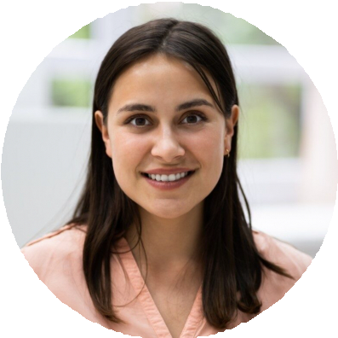
Venipuncture and capillary draws Pediatric and geriatric collections
Difﬁcult stick / fragile vein technique
Epic Beaker, Cerner Millennium
Order of draw and additive knowledge
Specimen processing and centrifugation
Chain-of-custody (DOT) Bilingual: English / Spanish
Drew 45 to 55 outpatient walk-ins per shift covering fasting glucose, lipid panels, and PT/INR.
Performed bedside collections at 4 long-term care partners, covering routes between 5 a.m. and 11 a.m.
Helped move the site from paper requisitions to barcoded labels, cutting mislabel events to near zero within 2 months.
Maintained chain-of-custody for DOT urine drug screens and pre-employment panels.

Education
Certiﬁed Phlebotomy Technician (CPT)
National Healthcareer Association, 2020,

Phlebotomy Certiﬁcate Program
Pima Community College, 2020,

BLS for Healthcare Providers
American Heart Association (current through 2025),

