Stephanie Young
Medical Surgical Nurse

Med-surg staff nurse with 4 years on a 30-bed orthopedic and general surgery unit. Strong post-op pain management, anticoagulation teaching, and early mobilization. Resource nurse for joint replacement protocol and CMSRN candidate sitting for exam in fall 2025.
PROFESSIONAL EXPERIENCE

CONTACT INFORMATION

(612) 555-0173

hannah.okafor@email.com Minneapolis, MN 12345

KEY SKILLS

Post-op orthopedic recovery and early mobilization
PCA, epidural, and peripheral nerve block management
Anticoagulation teaching (warfarin, DOACs, Lovenox)
Wound vac, JP drains, and incision care
Epic Inpatient and Rover
ERAS pathway and SCD compliance auditing
Float pool cross-training (oncology, renal, GI)
Preceptorship and peer review
SBAR handoff and bedside shift report
2022 - Present
Staff Nurse, Orthopedic-Surgical Unit | Northstar Lakeside Hospital, Minneapolis, MN
Manage a 5-patient post-op assignment with focus on total joints, spine fusion, and general surgery recoveries.
Reduced post-op day-one ambulation delays on my shifts by roughly 30% by coordinating early with PT and pain management.
Serve as unit resource for the enhanced recovery after surgery (ERAS) joint pathway and audit compliance monthly.
Trained 6 float pool nurses on the unit's PCA, epidural, and continuous nerve block workflows.
Active member of the unit practice council, leading the 2024 SCD compliance initiative.
2021 - 2022
Registered Nurse, Medical-Surgical Float Pool | Northstar Lakeside Hospital, Minneapolis, MN
Floated across 4 adult med-surg units, including oncology overflow and renal/GI, with 5-6 patient ratios.
Completed cross-training in chemotherapy administration basics and PD/HD patient handoffs.
Selected for nursing peer review committee within first year as RN.
2020 - 2021
Graduate Nurse Resident, Med-Surg | Northstar Lakeside Hospital, Minneapolis, MN
Completed 12-month Vizient/AACN-accredited nurse residency with capstone on hand hygiene compliance.
Progressed from 3 to 5 patient assignments by week 16 of orientation.
Earned safety star award for catching a heparin pump programming error on day shift.

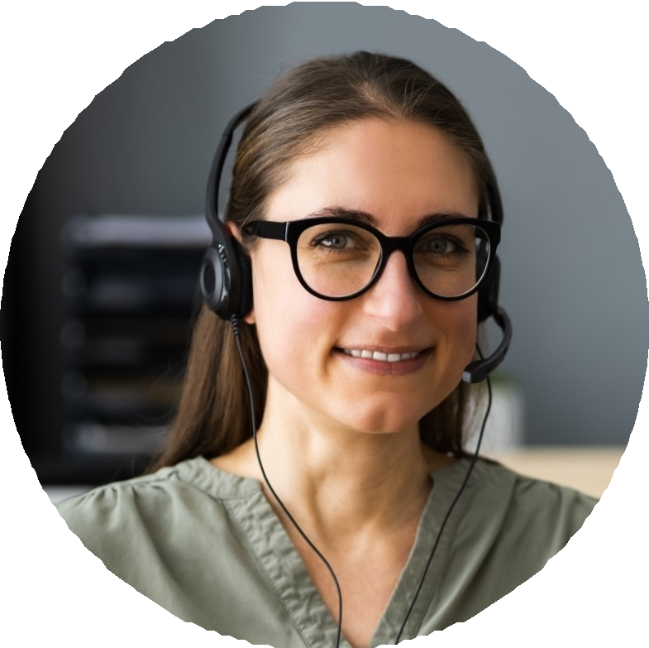


EDUCATION
Bachelor of Science in Nursing (BSN), University of Minnesota, 2020 RN License, Minnesota #RN-554120
BLS and ACLS, American Heart Association CMSRN Candidate, exam scheduled October 2025

