DEVON PRITCHARD
RDH-EFDA
Expanded Functions Dental Assistant with 11 years across oral surgery, orthodontics, and large group general practice. Trusted with surgical setups, IV sedation monitoring, and onboarding new assistants. Known for keeping providers on schedule and bringing structure to sterilization and OSHA programs.

Contact information

(216) 555-0173

devon.pritchard@example.com linkedin.com/in/devonpritchard Cleveland, OH

Education

AAS, Dental Hygiene Cuyahoga Community College, Cleveland, OH
March 2013

EFDA Certiﬁcation, #EFDA-22418 Ohio State Dental Board

DANB Certiﬁed Dental Assistant (CDA)

BLS and ACLS, American Heart Association

Key skills

Surgical and implant assisting IV sedation monitoring Coronal restoration placement
Orthodontic banding and wire changes
iTero and CBCT imaging
Sterilization program management
OSHA and HIPAA compliance Dentrix, Dolphin, Eaglesoft Staff training and mentorship
Inventory and vendor management

Professional experience
Lead Dental Assistant (EFDA) | Lakeshore Oral and Maxillofacial Surgery, Cleveland, OH
February 2020 - Present

Lead a team of 6 assistants supporting 3 surgeons through 45-55 implant and third molar cases per week
Rebuilt the sterilization workflow after a state inspection finding, with zero deficiencies on the next two audits
Monitor patients during IV moderate sedation, including vitals, pulse oximetry, and recovery protocols
Manage instrument cassettes and surgical supply par levels, holding inventory variance under $1,200 per quarter
Train new EFDAs on suture removal, coronal polishing, and post-op patient education

Orthodontic Assistant | Heights Orthodontic Group, Shaker Heights, OH November 2017 - March 2020
Placed and removed brackets, archwires, and elastics for 35-40 patients per day
Took intraoral scans and panoramic X-rays for treatment planning with Invisalign and traditional braces
Coached teens and parents through oral hygiene routines during banding appointments
Maintained Dolphin imaging records and assisted with insurance documentation for ortho claims

Dental Assistant II | Cuyahoga Family Dental Partners, Parma, OH February 2014 - November 2017
Assisted 4 general dentists across a 9-chair practice with crowns, endo, and pediatric procedures
Placed coronal restorations and packed retraction cord under EFDA certification
Took over weekly OSHA log audits and brought the practice into full compliance
Mentored 4 dental assisting students completing externship rotations

Dental Assistant | Mapleton Dental Care, Lakewood, OH March 2013 - November 2014

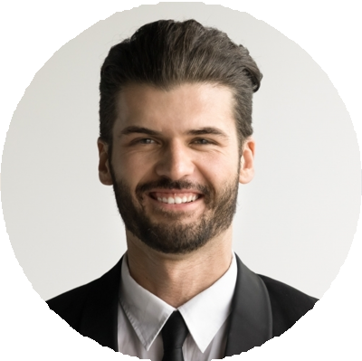




Supported chairside procedures including amalgams, composites, and prophylaxis appointments
Processed digital X-rays and maintained patient records in Dentrix

Handled daily instrument sterilization and operatory turnover between 22 patients per day

