HELENA S. MARCHETTI
Counsel with eleven years in life sciences regulatory and FDA practice, advising biotech and medical device companies on product development, clinical trials, and post-market compliance. Recognized internal expert on combination products and software-as-a-medical-device frameworks.





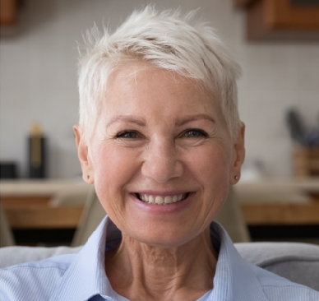

C O N T A C T

(617) 555-0119

h.marchetti@example.com Linkedin.com/in/helenamarchetti Boston, MA

K E Y S K I L L S
FDA regulatory strategy 510(k), De Novo, PMA
submissions
Software as a Medical Device (SaMD)
Combination products Clinical trial and IND advising
Warning letter and 483 response HIPAA and healthcare privacy Regulatory diligence for M&A
Client training and CLE presentations
Associate development and supervision

PROFESSIONAL EXPERIENCE
June 2020 - Present
Counsel, FDA and Life Sciences | Greymont Sayers LLP | Boston, MA

Lead regulatory diligence on roughly 18 life sciences transactions per year, including a $640M acquisition of a Series C diagnostics company.
Advise on IND, 510(k), De Novo, and PMA submissions; primary author on FDA pre-submission packages for four SaMD clients.
Run the ﬁrm's quarterly client roundtable on FDA digital health policy, attended by general counsel from 40+ companies.
Manage warning letter responses and Form 483 remediation plans; closed out a three-site CAPA matter for a Class III device maker in 14 months.
Mentor and supervise three associates; serve on the ﬁrm's professional development committee for the regulatory group.
February 2016 - June 2020
Senior Associate, Healthcare Regulatory | Donhauer Klein PC | Philadelphia, PA

Counseled hospital systems and digital health startups on HIPAA, anti-kickback, and Stark compliance.
Wrote enforcement-defense submissions to OCR and state AGs on data-breach matters affecting up to 280,000 patients.
Built a ﬁxed-fee compliance package for early-stage telehealth clients, used by 22 companies in two years.
Co-authored two ABA Health Law publications on remote patient monitoring.
EDUCATION
J.D., Harvard Law School, 2014
Ph.D. Molecular Biology, Johns Hopkins University, 2011
B.S. Biochemistry, Tufts University, 2005
Bar Admissions: Massachusetts (2014), Pennsylvania (2016), District of Columbia (2018)

