MAYA OKONKWO
Licensed Clinical Social Worker with seven years across hospital, outpatient, and crisis settings. Carry mixed caseloads of trauma, mood disorders, and SUD clients while supervising MSW interns. Bilingual in English and Spanish.

CONTACT INFORMATION

(503) 555-0148

PROFESSIONAL EXPERIENCE
LICENSED CLINICAL SOCIAL WORKER | CASCADE BEHAVIORAL HEALTH PARTNERS, PORTLAND, OR
FEBRUARY 2021 – PRESENT

m.okonkwo@example.co m

linkedin.com/in/mayaokonkwo LCSW Portland, OR

KEY SKILLS
- Manage caseload of 42 outpatient clients with diagnoses ranging from PTSD to bipolar II; reduced average no-show rate from 22% to 9% over 14
months by introducing reminder calls and warm handoffs.
- Lead weekly DBT skills group of 8 to 10 adults; about three-quarters of graduates met treatment goals within 6 months per PHQ-9 and GAD-7
tracking.
- Supervise two second-year MSW interns toward LCSW licensure hours, including weekly case consultation and chart review.
- Co-developed sliding-scale fee policy that expanded uninsured access while keeping clinic margin within budget.

  - DBT and CBT individual therapy
  - Trauma-informed assessment (PCL-5, ACE)
  - Crisis de-escalation and safety planning
  - Epic and SimplePractice EHR
  - MSW intern supervision
  - Spanish-language clinical interviewing
  - Discharge planning and care coordination

MEDICAL SOCIAL WORKER | RIVERBEND REGIONAL HOSPITAL, SALEM, OR
JUNE 2018 – JANUARY 2021
    - Completed 12 to 18 psychosocial assessments per week across med-surg and oncology floors, coordinating discharge planning with case managers
and family.
    - Connected 240+ patients annually to SNF, hospice, and home health services; documented in Epic within 24 hours of consult.
    - Served on hospital ethics committee, advising on three end-of-life cases involving disputed advance directives.
    - Trained nursing staff on identifying signs of elder abuse, leading to a noticeable uptick in APS referrals from inpatient units.

EDUCATION




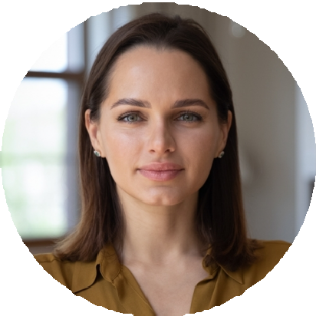
  - Mandated reporting and APS protocols
  - MSW, Clinical Concentration, Portland State University | May 2018
  - BA, Psychology, University of Oregon | May 2015
LCSW, Oregon Board of Licensed Social Workers, License #L-08842

