MARISOL
DELGADO

CCMA
Certiﬁed Clinical Medical Assistant with 4 years of experience in family medicine and multi-specialty clinics. Comfortable rooming 28-32 patients per shift while keeping wait times under 15 minutes. Bilingual (English/Spanish) and known by providers for clean chart prep and accurate vitals.

CONTACT INFORMATION
PROFESSIONAL EXPERIENCE
CLINICAL MEDICAL ASSISTANT | BRIGHTLEAF FAMILY HEALTH , RALEIGH, NC
FEBRUARY 2022 – PRESENT

(919) 555-0148

marisol.delgado@exampl e.com

linkedin.com/in/marisoldelgado Raleigh, NC

KEY SKILLS
- Room and prep an average of 30 patients per day across 3 providers, with vitals charted in eClinicalWorks before the provider enters the exam room.
- Run point-of-care testing including A1c, strep, flu, urinalysis, and EKGs; flagged an abnormal EKG that led to a same-day cardiology referral.
- Administer vaccines and injections per protocol (Td, MMR, B12, Depo, flu) and reconciled the vaccine fridge log to pass two consecutive state audits
with zero findings.
- Trained 4 new MAs on rooming workflow and EMR shortcuts, cutting their ramp time from about 6 weeks to 3.
- Translate for Spanish-speaking patients during visits and after-visit summaries, reducing no-show callbacks for that panel.

  - eClinicalWorks, Epic, Athenahealth
  - Vitals, EKG, phlebotomy, injections

MEDICAL ASSISTANT | PIEDMONT INTERNAL MEDICINE GROUP , DURHAM, NC
JUNE 2020 – JANUARY 2022

  - Point-of-care testing (A1c, strep, flu, UA)
  - Vaccine administration and VFC documentation
  - Prior authorizations and referrals
  - Patient intake and chart prep
  - Sterile technique and autoclave
    - Supported 2 internists in a high-volume practice averaging 45 visits per day; kept rooming-to-provider handoff under 4 minutes.
    - Performed blood draws and specimen collection, with a redraw rate below 2% over my last full year.
    - Processed prior authorizations for imaging and specialty referrals, closing most within 48 hours by pre-staging clinical notes.
    - Managed the front-desk overflow during staffing gaps, scheduling and verifying insurance for 20+ patients per day.

EDUCATION

  - HIPAA compliance
  - Bilingual: English/Spanish
  - Diploma, Medical Assisting, Wake Tech Community College | May 2020




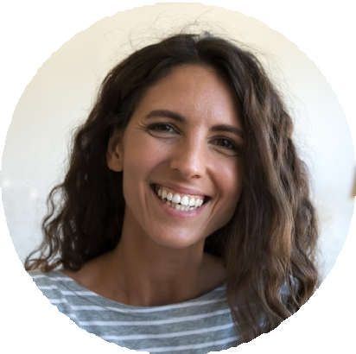
  - ICD-10 and CPT basics
  - CCMA, National Healthcareer Association, current through 2026
  - BLS for Healthcare Providers, American Heart Association

