DEVON
PRITCHARD
Reliable background actor with 30+ days on set across feature and episodic productions in the Atlanta market. Known for hitting marks on the ﬁrst take, holding continuity across long shoot days, and taking AD direction without notes twice.

CONTACT INFORMATION
EXPERIENCE

 (404) 555-0117
 devon.pritchard@example.com  linkedin.com/in/devonpritchard  Atlanta, GA

EDUCATION
BACKGROUND ACTOR (NON-UNION) | PEACH TREE EXTRAS CASTING | ATLANTA, GA | 2023-PRESENT

Worked 34 booked days across 6 feature and streaming productions in 14 months
Held featured background positions including diner patron, hospital staff, and concert crowd
Brought 4 wardrobe options per call to align with period and color palette
Tracked continuity across multi-day scenes with photo references on personal phone

On-Camera Background Workshop Atlanta Film Society, 2023

BA in Communications Georgia State University, 2022

SKILLS

STAND-IN / PHOTO DOUBLE | MAGNOLIA AVENUE PRODUCTIONS | SAVANNAH, GA | 2024

Stood in for a series lead through 3 weeks of principal photography on a half-hour comedy
Held blocking and eyelines while DP and gaffer set lighting
Logged off-camera lines with script supervisor during rehearsal blocking

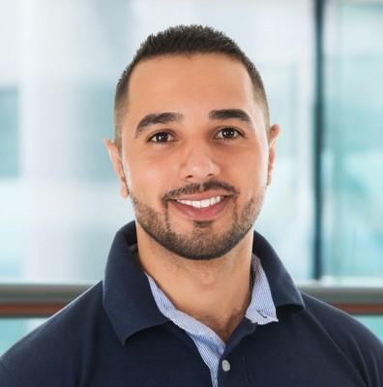

- Set etiquette: silent on set, holding for playback, returning to one
- Wardrobe range: business, scrubs, blue collar, period 1990s
- Driving: valid GA license, comfortable with picture cars
- Available with 6-hour notice within metro Atlanta

