DEVON
ALDRIDGE
Master esthetician with 12 years across med spa, dermatology, and resort settings. Expert in advanced modalities (microneedling, dermaplaning, jet peels) and team leadership. Built a six-ﬁgure book through clinical results, honest consults, and steady referral relationships with two local dermatologists.

CONTACT INFORMATION
PROFESSIONAL EXPERIENCE

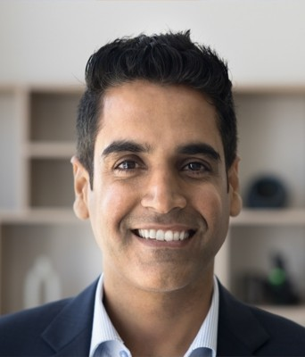




(912) 555-0190

devon.aldridge@example.com Linkedin.com/in/devonaldridge Savannah, GA

EDUCATION
Master Esthetics Program (1,200 hours)
May 2012
Aiken Institute of Esthetics

Georgia Esthetician License #ES-44218 | South Carolina Esthetician License #EST-22987
Certiﬁed Advanced Microneedling Practitioner, SkinPen, 2019
Jet Peel Certiﬁcation, AquaPure, 2021

KEY SKILLS
Microneedling and PRP support
Chemical peels (deep and medium depth)
Dermaplaning and jet peel
Post-laser and post-procedure care Medical charting and HIPAA
P&L and inventory management
Membership program design Boulevard, Zenoti, Nextech EMR

Spa Director & Master Esthetician | February 2020 - Present Magnolia Aesthetics Group | Savannah, GA

- Lead a team of 9 estheticians and 2 coordinators across two clinic locations.
- Grew annual service revenue from $612,000 to $1.05M over three years through a membership program and a reﬁned treatment menu.
- Negotiated wholesale contracts with 4 vendors, cutting backbar costs by roughly 22% year over year.
- Built training curriculum for microneedling and chemical peels; 100% of new hires pass internal certiﬁcation within 60 days.
- Maintain personal book of 280 active clients with a 12-month retention rate above 75%.

Lead Medical Esthetician | June 2016 - January 2020 Coastal Dermatology Partners | Charleston, SC

- Performed 35-45 clinical services weekly including chemical peels, dermaplaning, and post-procedure care.
- Partnered with 3 physicians on patient skincare plans for acne, melasma, and post-laser recovery.
- Hit personal sales of $187,000 in 2019 across services and physician-dispensed skincare.
- Trained 6 new estheticians on EMR charting, consent forms, and HIPAA-aligned documentation.
- Cut no-show rate from 14% to 6% by adding two-touch conﬁrmation texts and a deposit policy.
Esthetician | June 2013 - May 2016 Harborlight Resort Spa | Hilton Head, SC

- Delivered 28 weekly services in a luxury resort setting, including signature facials, body wraps, and gentleman's treatments.
- Ranked top 3 of 18 providers for guest satisfaction in 2014 and 2015.
- Mentored 5 newly licensed estheticians on resort-pace ﬂow and upselling add-ons.
- Helped redesign the seasonal menu, which lifted spring booking volume 18% the following year.

