Gary Mitchell
Front Desk Medical Receptionist
Front desk supervisor with 14 years across orthopedics, OB/GYN, and family medicine. Built check-in workﬂows that hold up during 100+ patient days and trained more than 20 receptionists across three clinic sites. Strong on insurance veriﬁcation, prior authorizations, and the awkward ﬁnancial conversations no one else wants to have.
PROFESSIONAL EXPERIENCE

C O N T A C T
I N F O R M A T I O N

(509) 555-0173

dolores.whitﬁeld@example.com Spokane, WA

K E Y S K I L L S

Epic NextGen
Practice Fusion Insurance veriﬁcation Prior authorizations Staff scheduling Front desk training
Patient ﬁnancial counseling HIPAA compliance Workers' comp intake
Medicare wellness scheduling Conﬂict de-escalation
2019 - Present
Front Desk Supervisor | Cascade Orthopedic Partners, Spokane, WA | 2019 to Present

Oversee a team of 9 receptionists across two clinic locations handling roughly 540 patient visits per week
Rebuilt the morning check-in script and intake packet, which dropped average check-in time from 7 minutes to under 4
Run weekly huddles on schedule gaps, no-show trends, and front-desk denial reasons with the billing manager
Audit insurance eligibility reports each morning and reach out to about 25 patients per week before their visit to ﬁx coverage issues
Write annual reviews, handle scheduling for PTO coverage, and sit on the EHR optimization committee
2015 - 2019
Lead Medical Receptionist | Inland Women's Health, Coeur d'Alene, ID | 2015 to 2019

Led front desk operations for a four-provider OB/GYN practice averaging 70 patient visits per day
Veriﬁed high-risk pregnancy beneﬁts with commercial and Medicaid plans and explained coverage to patients at intake
Coordinated referrals to maternal-fetal medicine, tracking each one through scheduling conﬁrmation
Cross-trained the medical assistants on after-hours phone triage routing during stafﬁng gaps
Cut outstanding patient balances over 60 days by about 22% through structured payment plans at check-in
2012 - 2015
Medical Receptionist | Riverbend Family Medicine, Pasco, WA | 2012 to 2015

Handled check-in, check-out, and phones for a three-provider rural family practice
Scheduled annual physicals, sports physicals, and Medicare wellness visits in Practice Fusion
Collected co-pays and outstanding balances, posting daily deposits of about
$1,800
Trained two replacement receptionists during a clinic transition to a new EHR




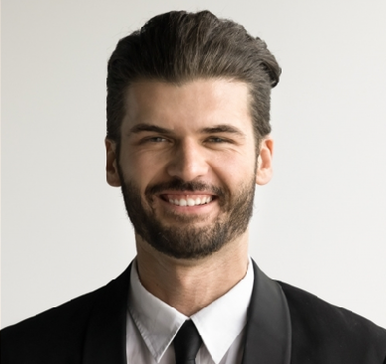
2010 - 2012
Patient Services Representative | Tri-City Urgent Care, Kennewick, WA | 2010 to 2012

Registered walk-in patients during 12-hour shifts averaging 80 visits per shift Veriﬁed insurance beneﬁts for urgent care and occupational health visits Processed workers' comp paperwork and faxed reports to employers same day Reconciled cash drawer nightly with zero variance for 14 months running
EDUCATION
Associate of Arts, Spokane Falls Community College, 2010

Certiﬁed Healthcare Access Associate (CHAA), NAHAM, 2018

