MARCUS DELANEY

Business Owner

Owner-operator running a multi-location specialty coffee company with 14 employees and two retail cafes. Built the business from a single mobile cart in 2017 to $1.8M in annual revenue, with wholesale accounts across four counties. Hands-on with sourcing, payroll, lease negotiation, and brand.

Professional Experience

Contact Information

(919) 555-0142

FOUNDER & OWNER | RIDGEPOINT COFFEE CO., RALEIGH, NC 2017 – PRESENT

marcus.delaney@example.co m

Raleigh, NC 12345

Key Skills
- P&L management and cash flow forecasting
- Commercial lease negotiation and site selection
- Grew annual revenue from $84K in year one to $1.82M in 2024 across two cafes and 11 wholesale accounts.
- Opened second location in 2022 on a 7-year lease; reached break-even in month 9, ahead of the 14-month plan.
- Hired and trained 14 staff including two shift leads; cut turnover from a high of 70% to roughly 30% by adding tipped wage floors and a written training
path.
- Negotiated direct-trade green coffee contracts with three farms in Colombia and Guatemala, lowering COGS by about 6 points.
- Manage all banking, payroll (Gusto), books (QuickBooks Online with a part-time bookkeeper), and quarterly tax filings.

  - Vendor sourcing and direct-trade contracting
OWNER | DELANEY MOBILE CART, LLC, RALEIGH, NC
2017 – 2019

  - Payroll administration (Gusto) and QuickBooks Online
  - Hiring, training, and retention programs
  - Wholesale account development and B2B sales
  - Ran a single espresso cart at farmers markets and corporate events 5-6 days per week.
  - Personally booked 80+ private events in the first 18 months through cold outreach and referrals.
  - Reinvested all profit into the first brick-and-mortar lease deposit and build-out.

  - Inventory and COGS management
ASSISTANT MANAGER | BREWLINE COFFEE BAR, DURHAM, NC 2014 – 2017

  - Pricing strategy and margin analysis
  - Brand development and local marketing
  - Health code compliance and food safety
  - Ran open and close shifts, managed inventory ordering, and trained new baristas.
  - Left to start own venture after three years of saving startup capital.

Education

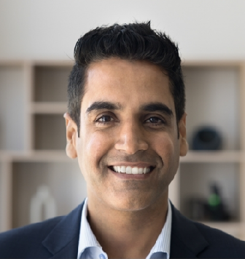


  - Multi-location operations management
  - POS systems (Square, Toast) and reporting
B.A. in Business Administration, North Carolina State University, 2013 Specialty Coffee Association (SCA) Certified Barista, Intermediate Level, 2018 ServSafe Food Protection Manager Certification, 2019

