ANDREW YOUNG

Artist
Santa Fe, NM 12345 | (505) 555-0179 | geoffrey.okonkwo@example.com

Professional Experience
Principal Artist
Okonkwo Studio, Santa Fe, NM | 2007 - Present

Senior painter and installation artist with 22 years of practice, museum representation in three states, and works held in 14 public and private collections. Active mentor, juror, and visiting critic across MFA programs in the Southwest.

Large-scale oil and mixed-media painting
Site-responsive installation
Gallery and museum relationships
Artist contracts and consignment review
Studio operations (multi-staff)
Board governance and committee leadership
Capital campaign fundraising
Graduate-level critique and mentorship
Monograph and catalog production
Estate and archive planning
Maintained continuous gallery representation since 2009; current primary gallery sells work in the $12,000 to $68,000 range.
Mounted 6 solo museum or institutional exhibitions, including a mid-career survey that drew about 11,000 visitors over 14 weeks.
Profile
Placed 14 works in permanent collections including two regional museums and a Fortune 500 corporate collection.
Run a studio with two full-time assistants and an annual operating budget around
$310,000.
Authored a monograph published in 2021; ﬁrst print run of 1,500 sold through within 9 months.
Key Skills

Visiting Critic and Juror
Multiple Institutions, Various, US | 2014 - Present

Served as visiting critic for MFA programs at UNM, ASU, and CalArts across 11 site visits.
Juried four regional fellowships and a national painting prize with a $25,000 award purse.
Mentor 3 to 5 early-career artists per year through structured studio visits and grant feedback.

Board Member, Vice Chair
High Desert Artist Trust, Santa Fe, NM | 2018 - Present

Co-led a capital campaign that closed at $1.8M against a $1.5M target for studio facility expansion.
Chaired the artist grants committee, overseeing distribution of about 40 awards per year.
Drafted the trust's ﬁrst conﬂict-of-interest and acquisitions policies, adopted unanimously by the board.
Recruited 4 new board members with curatorial and ﬁnance backgrounds.


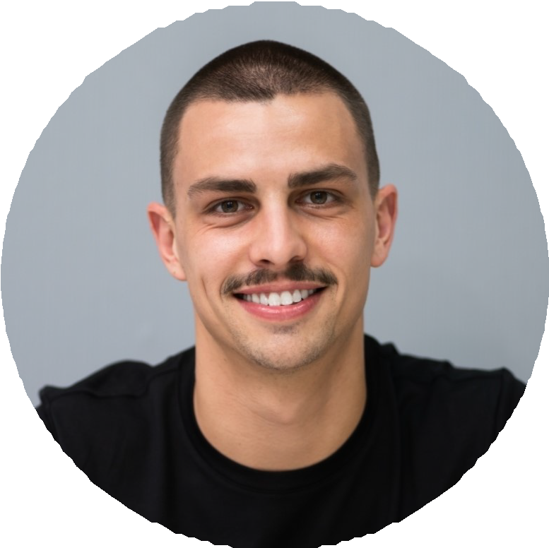
Adjunct Professor of Painting
Institute of American Indian Arts, Santa Fe, NM | 2011 - 2019

Taught upper-division painting and a graduate seminar in materials and conservation.
Revised the senior thesis review structure, cutting average time-to-completion by roughly four weeks.
Advised 28 graduating students; 9 placed in MFA programs and 4 received post-bac residencies.
Co-developed a cross-listed course with the Art History department that ran for six years.

Education
MFA, Painting, Yale School of Art, 2005
,

BFA, Painting, Cooper Union, 2002
,

