Barbara Wilson
Icu Nurse
ICU charge nurse with 12 years at the bedside and 4 years running night-shift charge on a 32-bed mixed adult ICU. Strong on staffing, throughput, and code leadership, with a parallel track in unit-based council work, sepsis quality, and new-hire onboarding.
Comfortable being the calm voice in the room when a unit is full and three rapid responses are pending.

CONTACT INFORMATION
(505) 555-0136

tomas.beltran@example.co m

Albuquerque, NM 12345

KEY SKILLS
ICU charge and bed ﬂow
Stafﬁng, acuity, and assignment building
Code blue and rapid response leadership
Sepsis bundle and SEP-1 review
ECMO and IABP support
CRRT and ventilator management
Preceptor and residency mentor
Unit-based council and shared governance
Epic super-user
Difﬁcult conversation and family meetings

PROFESSIONAL EXPERIENCE
2021 - Present
Charge Nurse, Adult ICU, Sandia Mesa Health System, Albuquerque, NM
- Run night charge on a 32-bed mixed medical/surgical ICU, balancing assignments for 11-13 RNs and 2 techs each shift.
- Coordinated bed flow during a 14-day surge that ran census at 104% capacity; held zero hallway boarders by working closely with ED and house supervisor.
- Lead code blue and rapid response teams overnight; debrief every event and feed themes into the monthly practice council.
- Cut new-hire 12-month turnover on night shift from roughly 1 in 3 to under 1 in 6 by redesigning the buddy-shift schedule with the educator.
- Sit on the hospital Sepsis Steering Committee; helped raise SEP-1 bundle compliance on the unit by about 18 points over two years.
2017 - 2021
Senior Staff Nurse, Adult ICU, Sandia Mesa Health System, Albuquerque, NM
- Primary RN for vented, CRRT, and balloon pump patients; relief charge 6-8 shifts per month.
- Built and taught the unit ECMO awareness module after the hospital launched its ECMO program in 2019.
- Served as unit super-user for Epic critical care flowsheet upgrade across three go-live weekends.
- Precepted 14 new graduate RNs through ICU residency; 12 are still on the unit or in advanced practice school.
2014 - 2017
ICU Staff Nurse, Coronado Valley Medical Center, Santa Fe, NM
- Cared for medical, surgical, and overflow trauma patients in a 12-bed community ICU.
- Took 1:1 assignments for fresh post-arrest TTM and high-acuity sepsis.
- Co-led the falls reduction project that brought ICU falls with injury down to 1 event for the year of 2016.
- Charge relief weekends; supported a small staff with limited float pool coverage.
2012 - 2014
Staff Nurse, Progressive Care Unit, Coronado Valley Medical Center, Santa Fe, NM

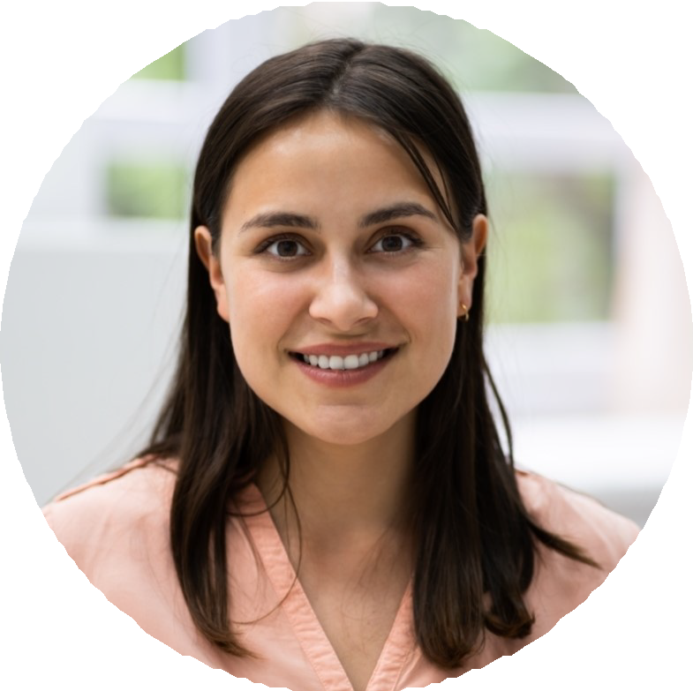



  - Carried 3-4 PCU patients on telemetry, drips, and BiPAP.
  - Joined the unit-based council as bedside rep; pushed for clearer pain reassessment workflow.
  - Trained as MET responder in second year of practice.

EDUCATION

Master of Science in Nursing, Nursing Leadership, University of New Mexico, 2020
Bachelor of Science in Nursing, New Mexico State University, 2012 CCRN (Adult) since 2016, CMC since 2019
BLS, ACLS, NIHSS instructor

