Brenda Mitchell
Makeup Artist

Freelance makeup artist with 7+ years across bridal, editorial, and short-form ﬁlm. Known for clean, skin-forward looks that photograph well in mixed lighting, plus calm on-set presence during back-to-back changes.


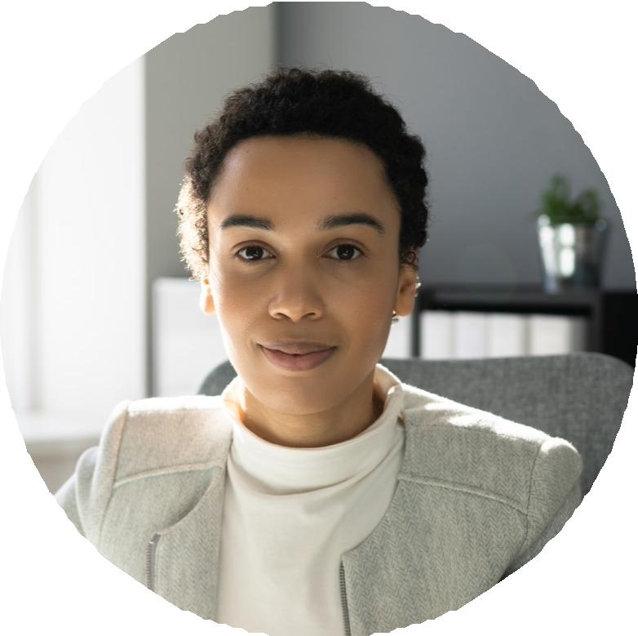




Contact Information

(912) 555-0143
mariela.quintero@example. com
Savannah, GA 12345

Education

Certiﬁcate in Professional Makeup Artistry, Cinema Makeup School (2017)

B.A., Studio Art, Georgia Southern University (2015)

Key Skills

Bridal and event makeup
HD and 4K-friendly base work Airbrush (Temptu, Iwata)
Soft-glam, editorial, and natural-skin looks
Cream and powder color theory across Fitzpatrick I-VI
Light SFX: bruising, aging, cuts, hair-whitening
Strip and individual lash application
Continuity tracking and on-set touch-ups
Kit sanitation and IATSE-aligned hygiene practices
Timeline planning for parties of 4-12

Professional Experience

Lead Makeup Artist (Freelance) | 2021 - Present
Pollen + Petal Beauty Co., Savannah, GA

Booked 84 bridal parties in 2023, averaging 6 faces per call with two assistants I trained and scheduled
Built a low-ﬂashback foundation kit after a videographer ﬂagged HD washout on a Lowcountry estate shoot
Maintained a 4.9 rating across The Knot and Google by following up with timeline edits the week of each event
Cut kit restock spend by switching to reﬁllable palettes for cream blush, lip, and cheek tones
Mentor for two associate artists working toward solo bridal bookings

Key Makeup Artist | 2019 - 2022
Tidewater Studios (short ﬁlm + commercial), Charleston, SC

Department head on a 9-day indie short, ran continuity book across 47 scenes and three principal cast
Designed aging makeup for a 70-year span on one lead using stipple, hair whitening, and forehead prosthetic
Coordinated with wardrobe and DP on a teal-and-rust palette that held under tungsten and natural light
Stayed under a tight per-diem kit budget by sharing consumables across two overlapping productions
Counter Artist & Makeup Educator | 2017 - 2019
Bobbi Brown / Belk ﬂagship, Atlanta, GA

Hit 118% of quarterly counter goal in Q4 2018 through pre-booked holiday lessons
Ran weekend skin tone matching clinics for clients ages 18 to 72 Trained four new hires on undertone reading and corrective concealing

