CALEB WHITFIELD
Event Manager
Event coordinator with two years supporting B2B webinars, regional roadshows, and customer dinners. Comfortable owning the RSVP funnel, vendor checklists, and on-site signage. Strong on follow-through and detail in pre-event week.
PROFESSIONAL EXPERIENCE




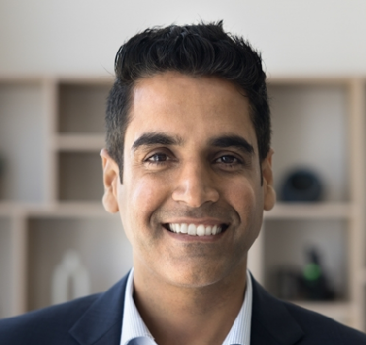

C O N T A C T
I N F O R M A T I O N

(480) 555-0146

caleb.whitﬁeld@example.com Tempe, AZ

K E Y S K I L L S

Cvent registration Splash
Marketo Notion
Vendor coordination Shipping and 3PL On-site check-in
Budget tracking under $50K Travel logistics
Slack
2023 - Present
Event Coordinator | Thresholdale SaaS, Tempe, AZ

Support 6-8 ﬁeld marketing events per quarter, handling registration, swag, badge production, and shipping.
Owned logistics for an executive dinner series of 14 events, hitting an average attend rate of 72% of registrants.
Cut shipping costs by switching to a regional 3PL after a quick vendor bake-off in Q2.
Built a vendor contact directory in Notion that the broader marketing team now references.
2022 - 2023
Marketing Events Assistant | Cinderhall University Alumni Ofﬁce, Flagstaff, AZ

Assisted on 9 alumni reunion weekends, including a homecoming event for 1,200 guests.
Handled name badge production, welcome kits, and check-in stations across 3 simultaneous venues.
Tracked donor RSVPs in Raiser's Edge and ﬂagged VIP travel needs to the events director.

EDUCATION
B.S., Marketing, Northern Arizona University, 2022

