RAYMOND
SANCHEZ
Makeup Artist

ABOUT ME

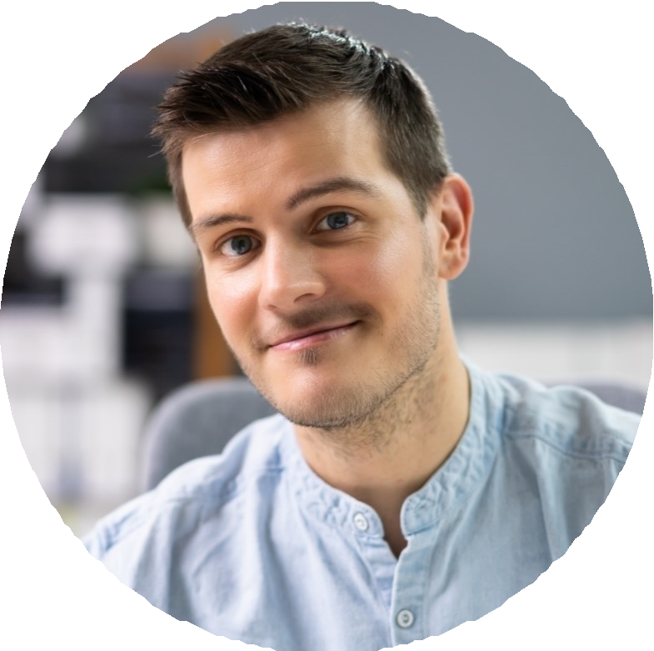

CONTACT INFORMATION

 (503) 555-0129

rowan.esperanza@example.c om
 Portland, OR 12345

KEY SKILLS
Department head budgeting and producer reporting
Prosthetic application, life-casting, and silicone touch-ups
HD and 8K camera-ready beauty and corrective makeup
Period and character design with continuity binders
Airbrush foundation and body makeup for tattoo coverage
Burn, wound, and trauma effects with bloodwork
Trailer setup, kit management, and bulk decant systems
Hiring, scheduling, and mentoring key and 2nd artists
Background and crowd makeup coordination at scale
Bridal and event production workﬂow
Union call sheet and turnaround compliance
Color matching across Fenty, MAC Pro, RCMA, and Kryolan kits
Department head makeup artist with 14 years across episodic TV, national commercials, and union features. IATSE Local 706 member. Builds and runs makeup trailers, hires and trains key and 2nd artists, and handles producer-facing budget conversations.

PROFESSIONAL EXPERIENCE
Makeup Department Head
Cedar Knoll Pictures (episodic, Season 2-3), Portland, OR | 2022 - Present
Run a 4-artist department across a 14-week shoot, 9 principals and 60+ recurring background per episode
Cut weekly trailer supply spend by $1,820 by switching to bulk decanted brushes and shared consumables
Designed a recurring burn-scar prosthetic that survived 23 takes per day with no re-application
Submit weekly continuity binders and product lists to producers and unit production manager
Mentor a key artist who moved up to department head on her own pilot in 2024

Key Makeup Artist
Brightline Commercial (national spots), Portland, OR | 2019 - 2022
Keyed 40+ national commercials for athletic, automotive, and CPG brands
Built a working relationship with three DPs that drove 60% of repeat bookings
Tested every new launch foundation in the kit against 8K monitor before set day
Hired and onboarded 2nd artists from a vetted local pool of 11

Lead Bridal & Event Artist
House of Linden Studio, Seattle, WA | 2016 - 2019
Built bridal arm from 18 to 132 weddings per year over three seasons
Hired and trained a team of 7 associate artists with a standard look-book and timing rubric
Set up a per-bride consultation ﬂow that cut day-of changes to under 10 minutes per face
Owned vendor relationships with 4 venues and 6 wedding planners

Makeup Artist
Freelance (editorial, theater, runway), Seattle, WA | 2011 - 2016

- Backstage credits at three Seattle Fashion Week seasons across 22 designers
- Theater design for a regional repertory company, 6 productions including a Shakespeare in the Park run
- Editorial work in two regional fashion books and one national online title
- Built ﬁrst prosthetics portfolio with a sculptor through nights and weekends

EDUCATION
Certiﬁcate in Film and Television Makeup, Cinema Makeup School, Los Angeles, CA, 2011
Certiﬁcate in Prosthetic Application and Sculpting, Vancouver Film School, 2013 IATSE Local 706 Member in Good Standing, 2018-Present
Bloodborne Pathogens and Set Safety Certiﬁcation, renewed 2024

