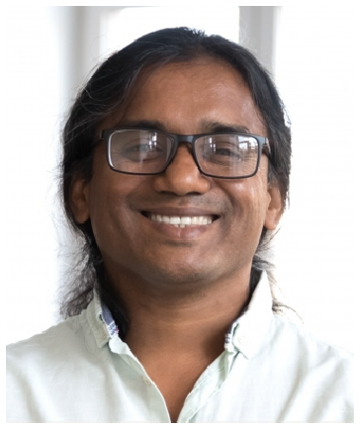
Contact information
 (801) 555-0119
 daniel.park@example.com  Salt Lake City, UT 12345

Education
M.S. COMPUTER SCIENCE, UNIVERSITY OF UTAH, 2010
B.S. COMPUTER SCIENCE, BRIGHAM YOUNG UNIVERSITY, 2008

Key skills
Distributed systems and multi-region architecture
Go, Java, Python, Rust
Kafka, gRPC, Envoy, Kubernetes
PostgreSQL, Cassandra, DynamoDB
AWS and GCP
Observability: Datadog, Honeycomb, OpenTelemetry
Incident command and postmortems
Technical strategy and RFC review
Mentoring senior and staff engineers
Hiring loops and calibration

Professional experience
STAFF SOFTWARE DEVELOPER | WAYFINDER COMMERCE, SALT LAKE CITY, UT | 2020 - PRESENT
DANIEL PARK
Software Developer

Staff developer with 14 years building large-scale distributed systems across e-commerce, gaming, and developer tools. Sets technical direction for multi-team initiatives and is the named owner on the company's reliability and data-platform roadmaps.

Technical owner of the order management platform, which handles roughly $1.3B in GMV per year across 6 brands.
Drove the multi-region active-active rollout; eliminated 4 prior single-region outages per year and got us to 99.97% availability.
Authored the company's service maturity rubric, now used quarterly by 11 engineering teams.
Mentor 3 senior engineers and chair the staff-plus technical review.
Partnered with product and ﬁnance to retire two internal services, freeing about 18% of the platform team's roadmap.

PRINCIPAL ENGINEER | BRIGHTFORGE STUDIOS, LEHI, UT | 2017 - 2020

Led design of the matchmaking backend serving 7 live games and around 14 million monthly players.
Replaced a homegrown queue with Kafka, cutting matchmaking p99 from 11s to under 2s.
Set the bar for postmortems, including blameless template and follow-up tracking in Jira.
Interviewed and onboarded 9 senior engineers during a hiring surge.
Acted as incident commander for the largest outage in company history; recovery doc became the training case study.

SENIOR SOFTWARE DEVELOPER | COBALT DEVELOPER TOOLS, PROVO, UT | 2013 - 2017

Built and maintained the CLI used by roughly 200,000 developers a month.
Owned plugin architecture and the public extension API.
Wrote three of the team's most-read internal design docs on plugin sandboxing.
Promoted from Developer to Senior in 2015.

SOFTWARE DEVELOPER | INKWELL WEB GROUP, OREM, UT | 2010 - 2013

Built features and ﬁxed bugs across a Rails-based CMS used by mid-market publishers.
Rewrote the image upload pipeline, cutting failed uploads by about a third.
Was ﬁrst responder on weekend pages during a 2-year rotation.

Helped onboard 4 junior developers.

